**FROM QUARKS TO THE COSMOS**

**Exercises**

**Section 39.1 Particles and Forces**

**19. Interpret** This problem involves finding the lifetime of a virtual photon by applying the uncertainty principle. If the photon were to live longer than the time allowed by the uncertainty principle, conservation of energy would be violated.

**Develop** In order to test the conservation of energy in a process involving a single virtual photon, a measurement of energy with uncertainty less than the photon’s energy 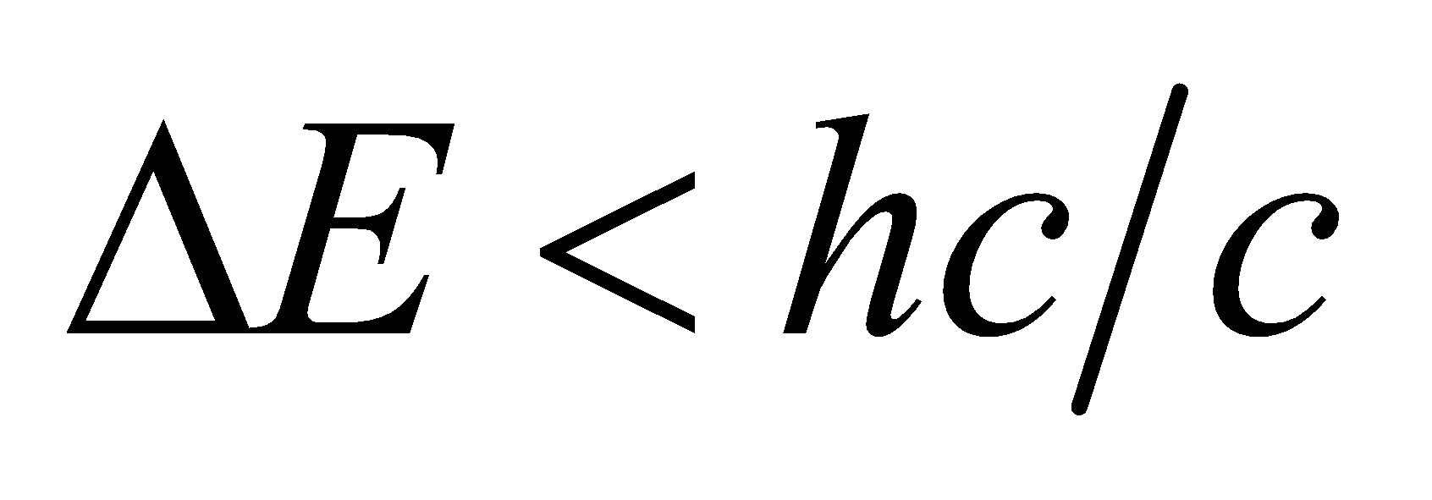 must be performed in a time interval *Δt* less than the virtual photon’s lifetime (i.e., *Δt* < *τ*). Thus, 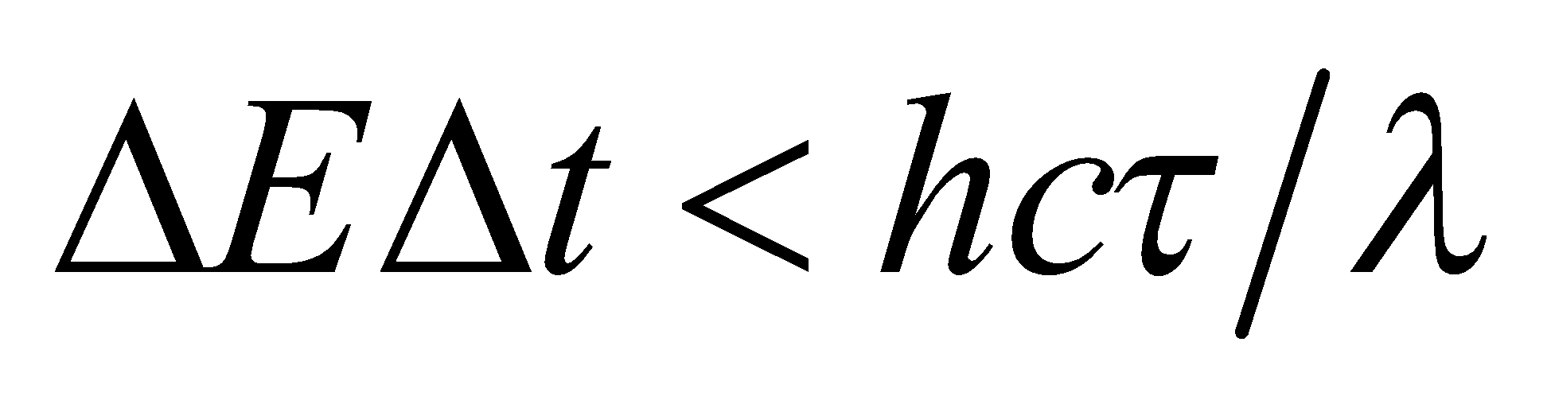. But Heisenberg’s uncertainty principle limits the product of these uncertainties to 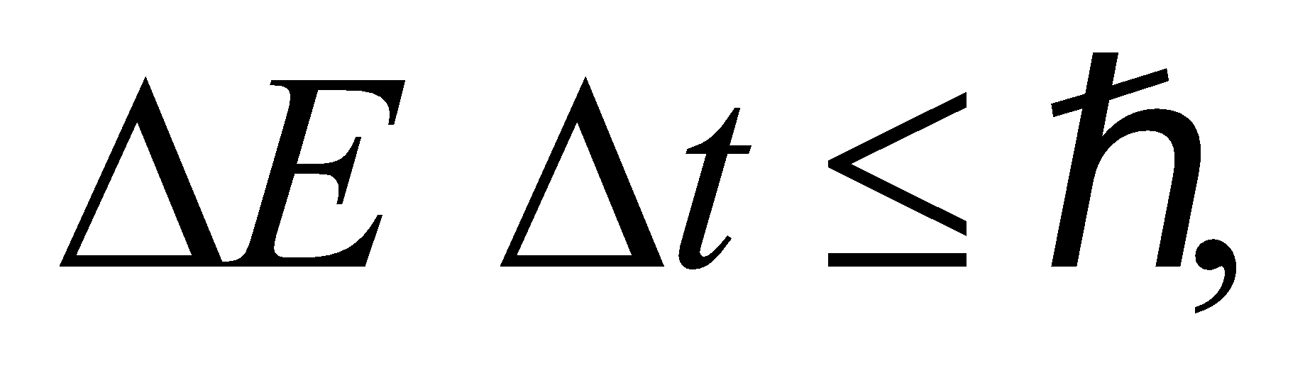 so 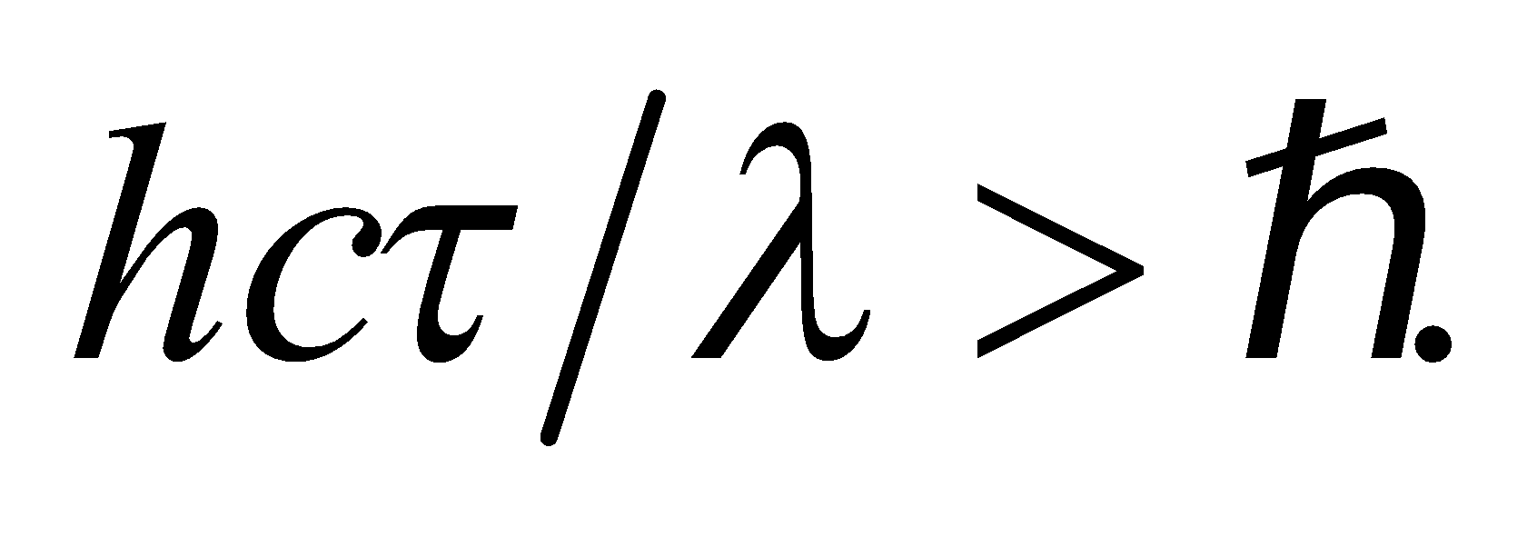 Knowing the wavelength allows us to find the upper bound on the lifetime of the virtual photon.

**Evaluate** With *λ* = 633 nm, we get

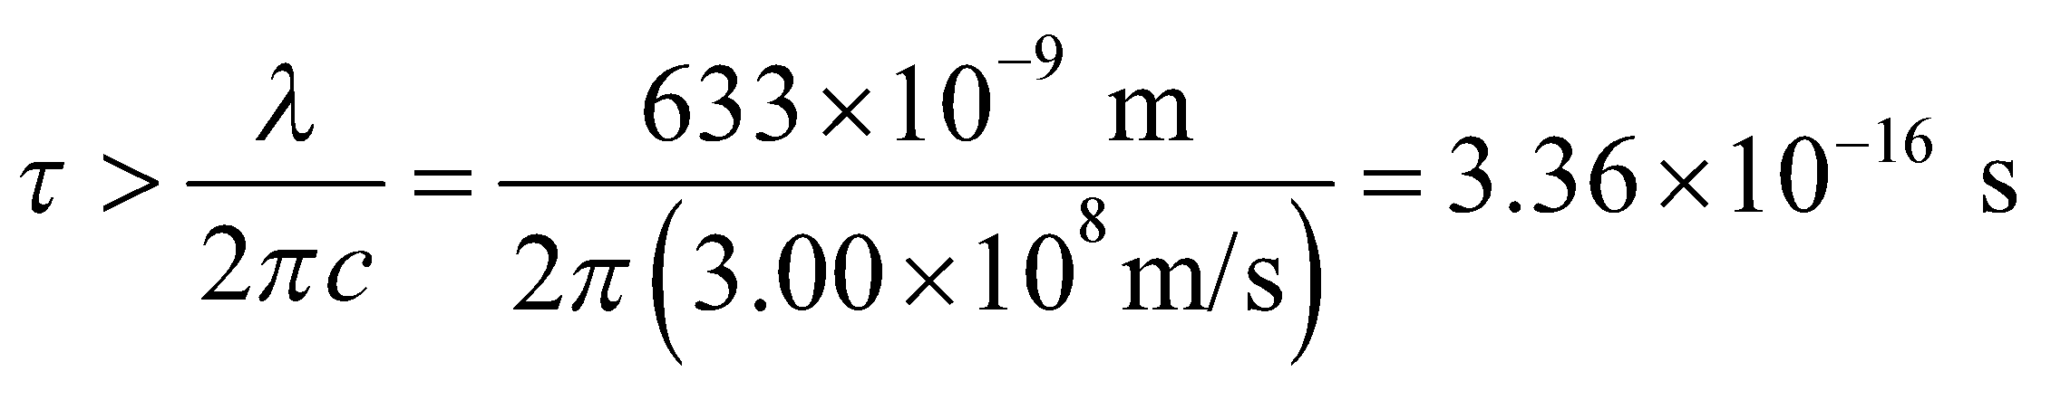

**Assess** If the lifetime of a virtual photon of wavelength 633 nm were less than 0.336 fs, no measurement showing a violation of conservation of energy would be possible.

**20. Interpret** We are to use Yukawa’s logic to estimate the mass of the particle that would mediate a force with a range of 100 m.

**Develop**  According to the version of Yukawa’s argument presented in the text, the relation between the mass of a field particle and the range of the force it mediates is

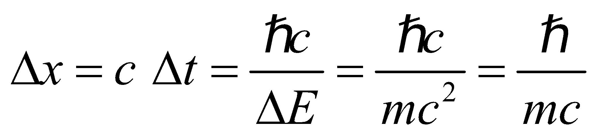

(i.e., the range of the force is approximately the Compton wavelength of the mediating field particle).

**Evaluate** Solving for the mass and inserting *Δx* = 100 m gives

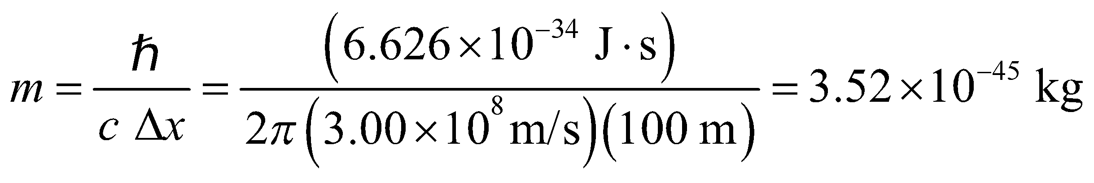

**Assess** The longer the range of the force, the smaller the mass of the mediating particle.

**Section 39.2 Particles and More Particles**

**21. Interpret** We are to write the reaction for the decay of a positive pion to a muon and a neutrino.

**Develop** The decay process must conserve both charge and lepton number *L* (see Table 39.1). The positive pion has charge +*e* and lepton number 0. The positive muon has charge +*e* and lepton number −1, because it is an antiparticle. To conserve change and lepton number, the neutrino must therefore have charge zero and lepton number 1. The muon neutrino satisfies these conservation requirements.

**Evaluate** The decay of the positive pion is

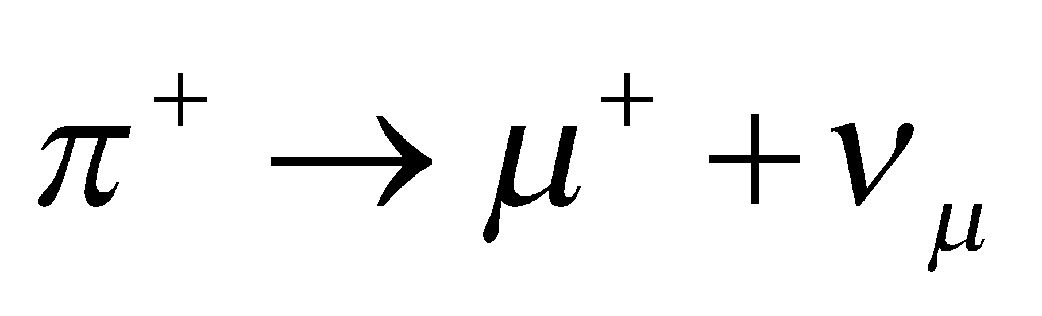

**Assess** Note that the lepton numbers of antiparticles are the opposite of those of their corresponding particles.

**22. Interpret** This problem involves analyzing the strangeness of a decay reaction to find the force involved in the reaction.

**Develop** From Table 39.1, we see that the 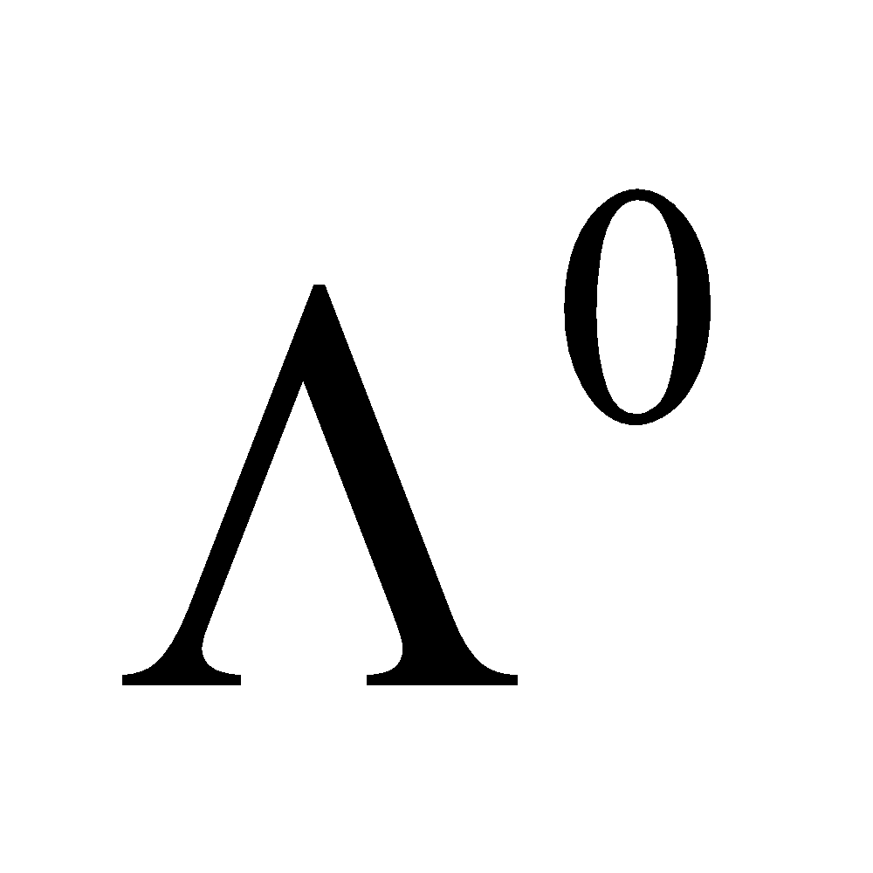 has strangeness −1, whereas the *p* and *π*− both have zero strangeness.

**Evaluate** Thus *ΔS* = 1 for this decay (final minus initial strangeness). Since strangeness is conserved in strong and electromagnetic interactions, the decay must be a weak interaction.

**Assess** Analyzing conservation laws is very useful in determining the forces involved.

**23. Interpret** We are asked to verify the conservation laws for the decay of 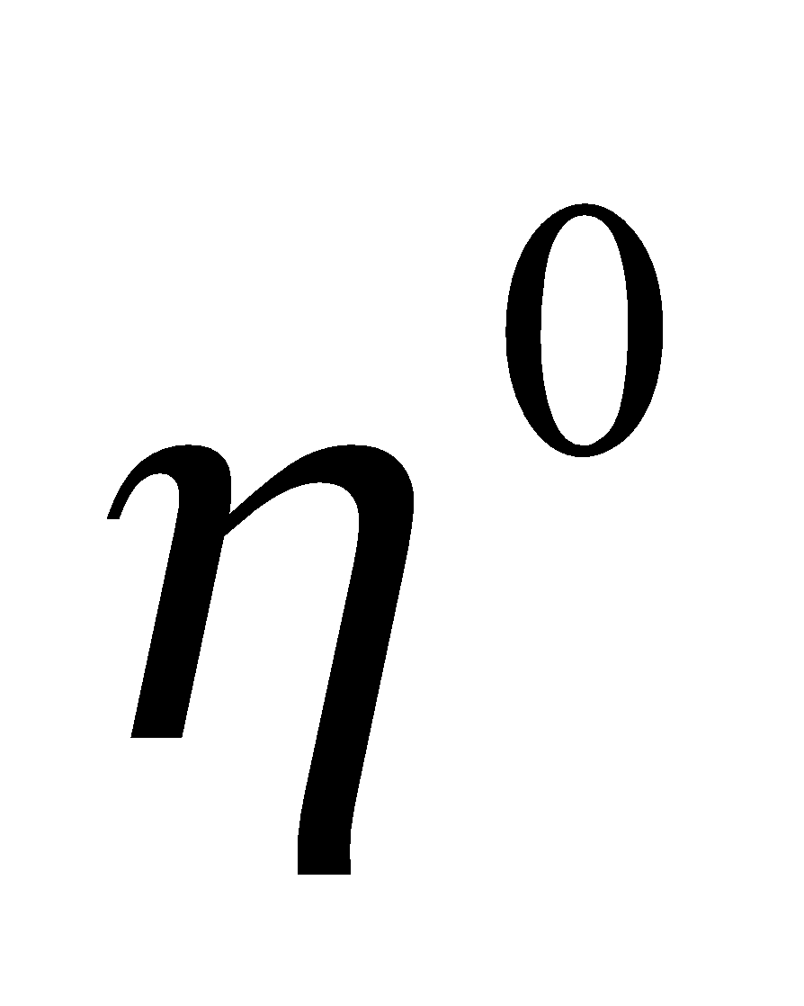 into a positive, a negative, and a neutral pion.

**Develop** The decay process 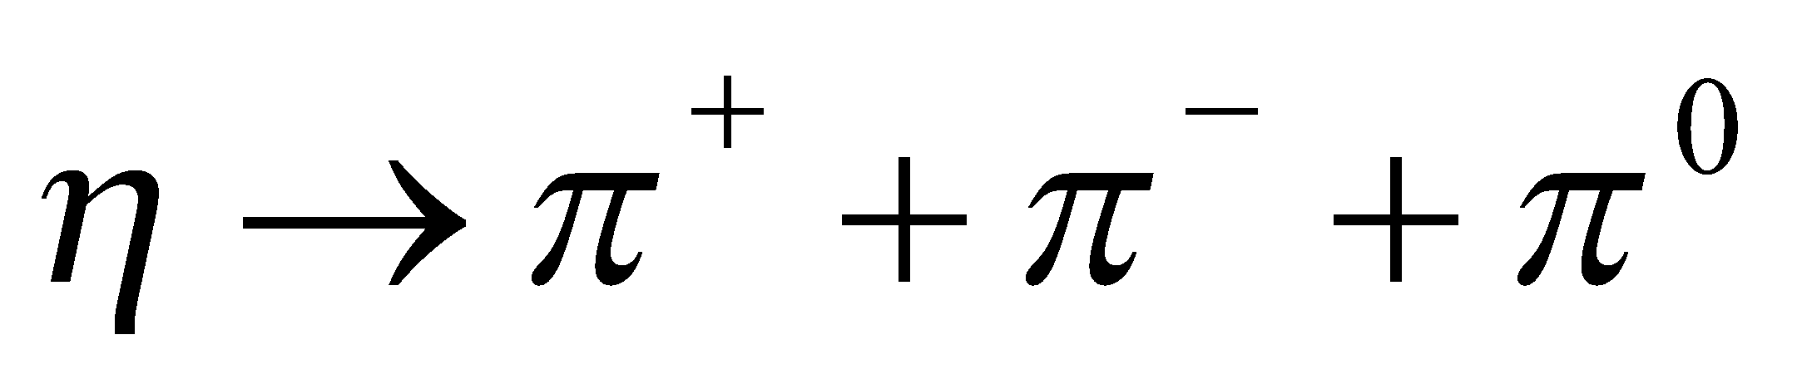 must conserve charge, strangeness, and baryon number (see Table 39.1).

**Evaluate** The decay conserves charge (0 = 1 − 1 + 0), and all the particles have zero baryon number and strangeness, so these quantities are conserved as well.

**Assess** The problem illustrates how conservation laws restrict the possible decay modes of a particle.

**24. Interpret** We are to determine which of the given reactions are allowed. We shall consider conservation of charge, lepton number, baryon number, and strangeness.

**Develop** Reference to Table 39.1 shows that both decays satisfy conservation of charge, electron-lepton number, and tau-lepton number (the negatively charged leptons are particles). None of the particles are baryons, weak decays don’t have to conserve strangeness, and the tau particle’s rest energy is greater than that of either final state.

**Evaluate** Both decays (a) and (b) are possible.

**Assess** The conservation laws allow us to determine which reactions are possible.

**25. Interpret** In this problem we are asked to apply conservation laws to decide if the give interaction is possible.

**Develop** The relevant properties to be considered here are charge, baryon number, and spin (see Table 39.1).

**Evaluate** The reaction 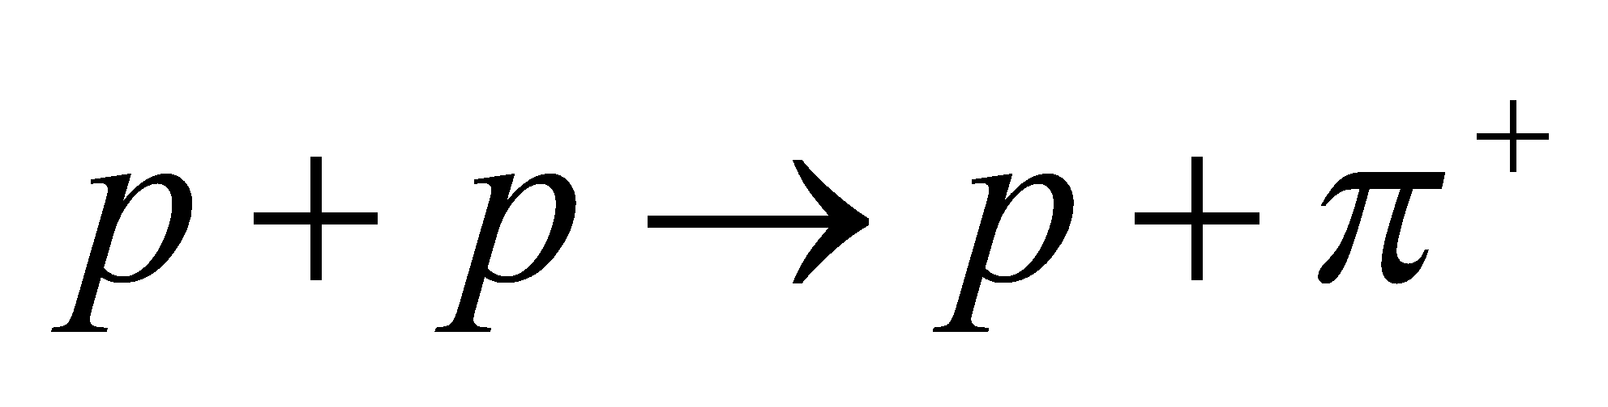 violates the conservation of baryon number 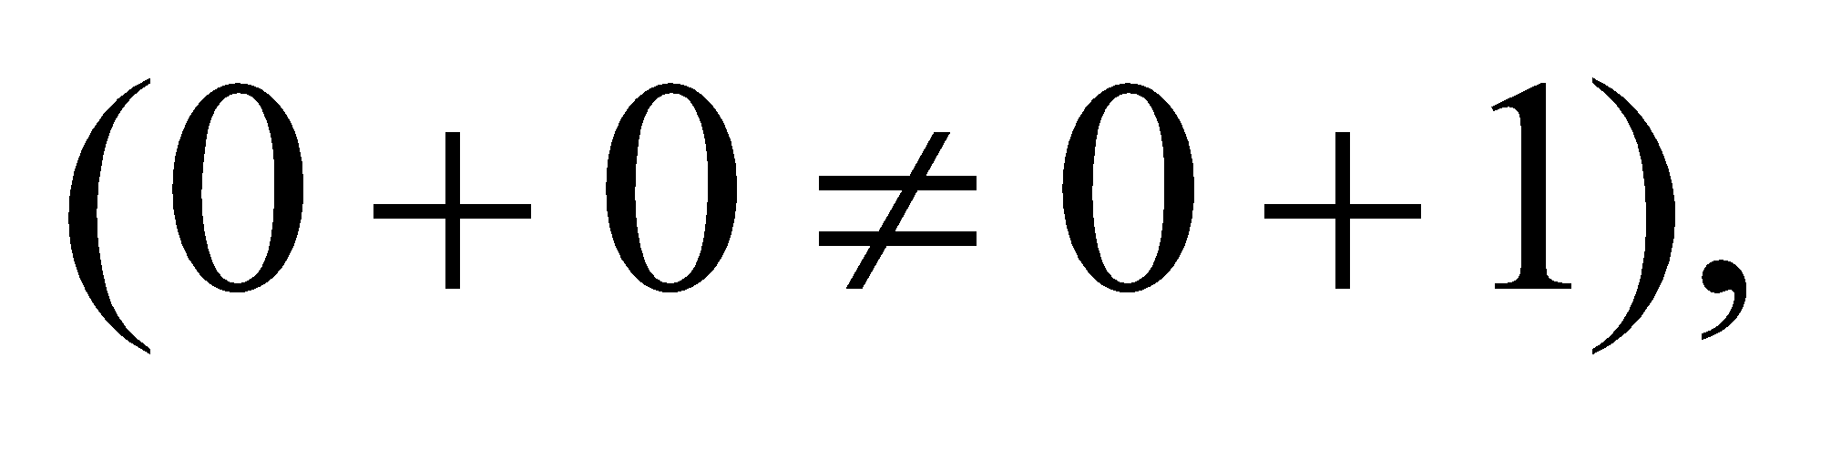 and also angular momentum, since the proton’s spin is 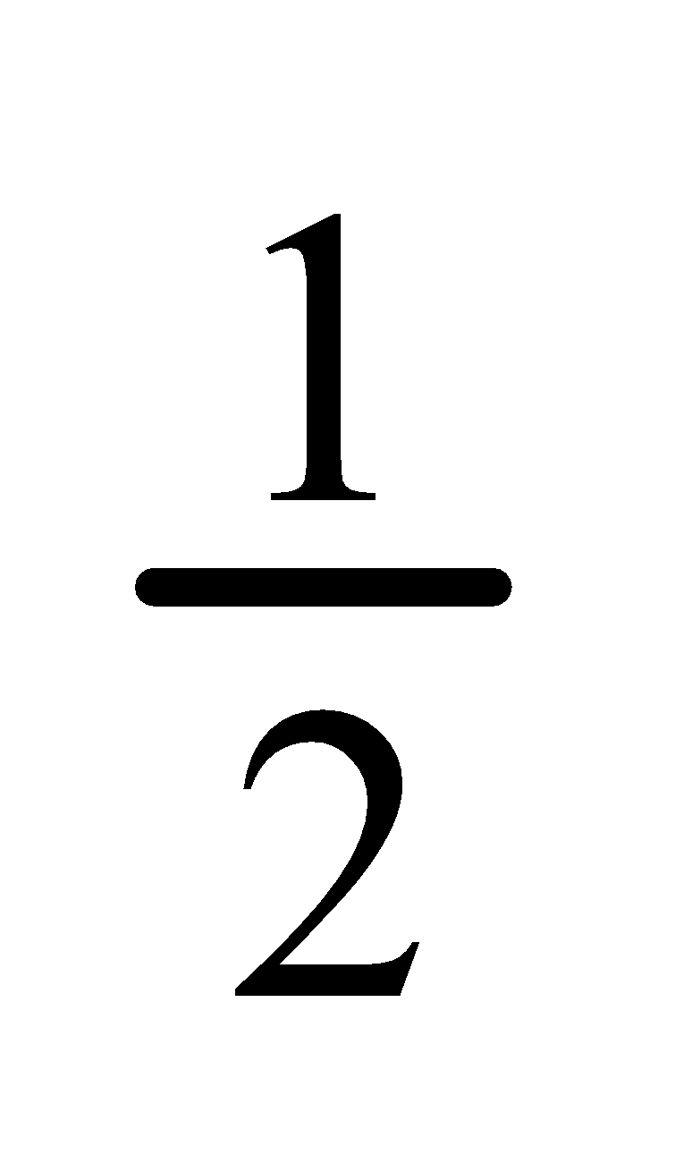 and the spin of the pion is 0. Therefore, the process is not allowed in the standard model with electro-weak unification.

**Assess** The problem illustrates how conservation laws restrict the possible outcomes of particle interactions.

**Section 39.3 Quarks and the Standard Model**

**26. Interpret** We are to determine the quark composition of the *π*−.

**Develop** From the text, we learn that mesons (such as the negative pi-meson, or pion) are made of quark-antiquark pairs. Table 39.1 tells us that the negative pion is negatively charged and has no strangeness.

**Evaluate** With the help of Table 39.2, we see that the only quark-antiquark pair with charge −*e* and no strangeness (i.e., charm, top, or bottom) is 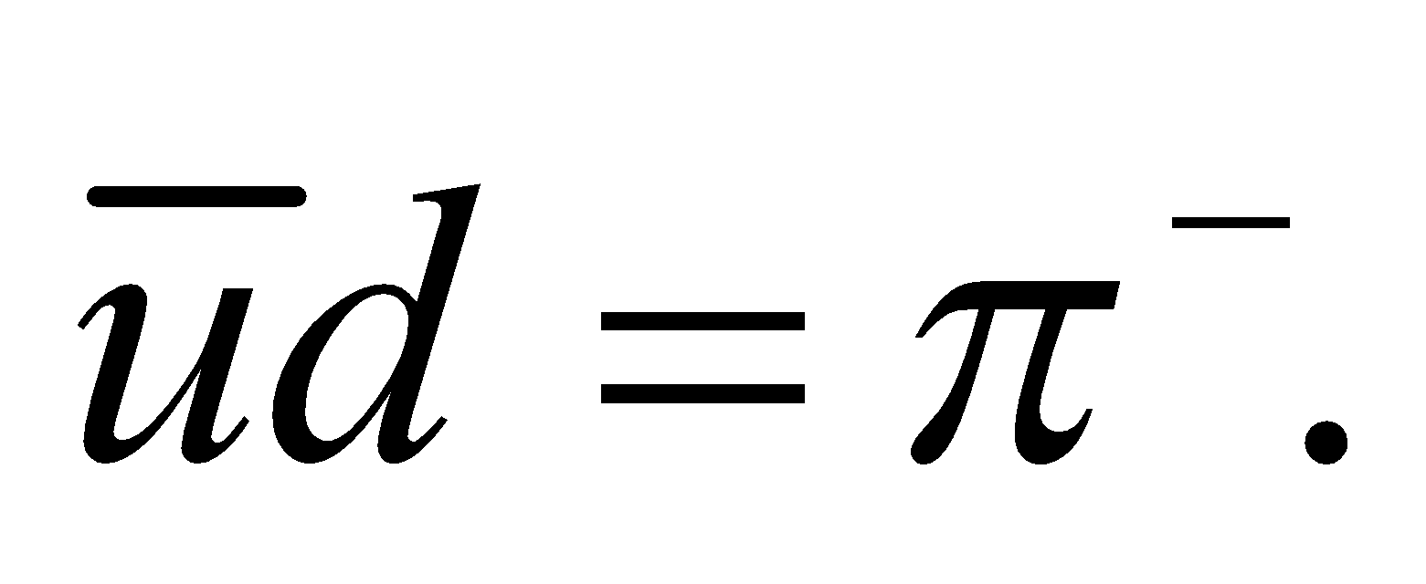

**Assess** Figure 39.5 shows the positive pion, which is made of the quarks 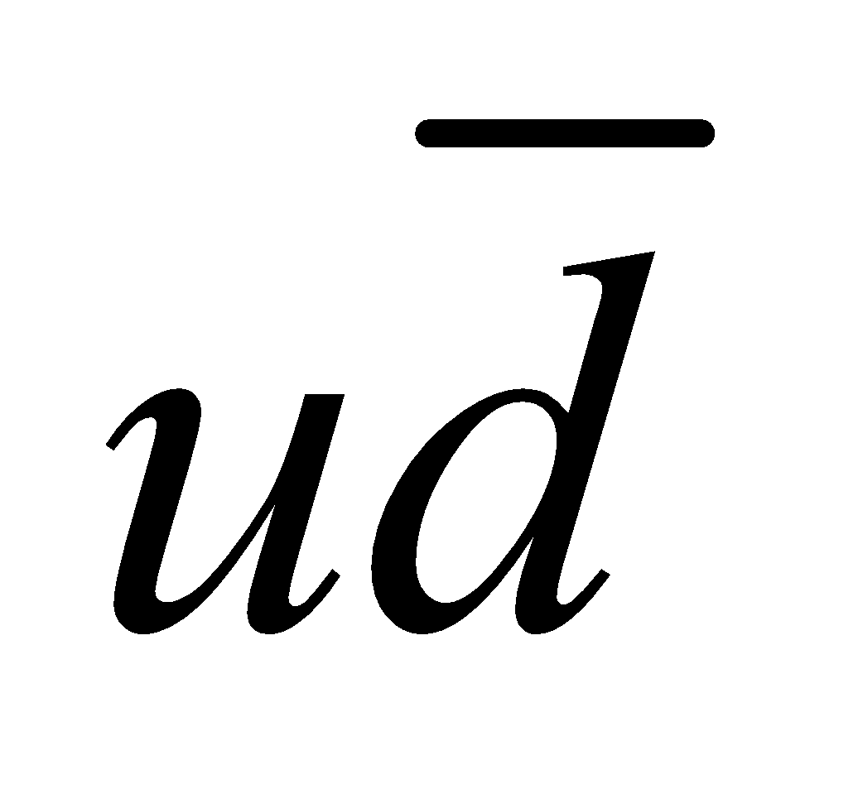.

**27. Interpret** We want to know the quark composition of a baryon with strangeness −3.

**Develop** A baryon is a particle that consists of three quarks. A strange quark has strangeness s = −1 and charge

−*e*/3 (see Table 39.2).

**Evaluate** The baryon that is composed of three strange quarks with strangeness s = −3 and charge −*e* is the 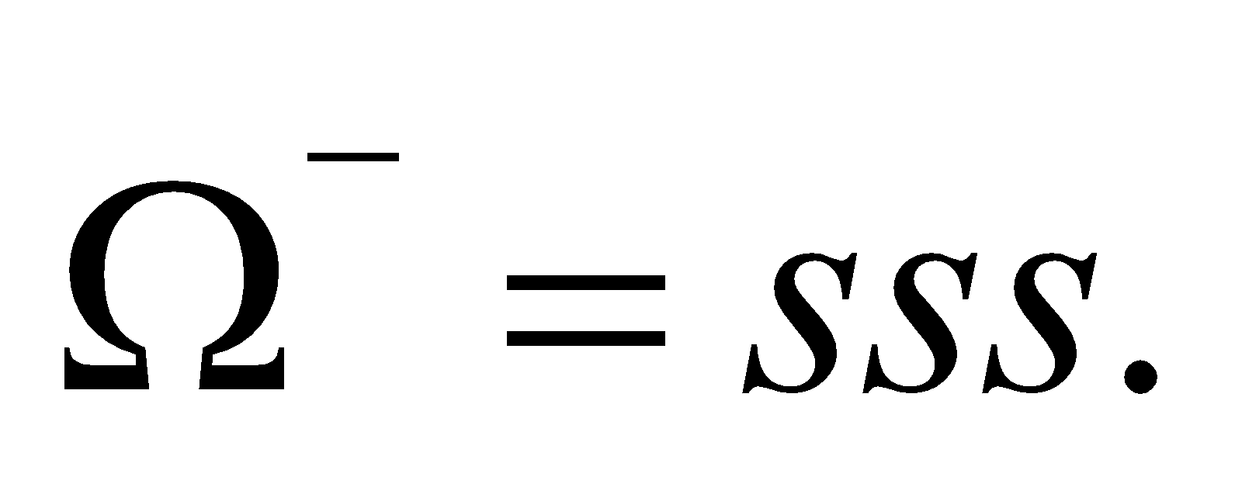

**Assess** Gell-Mann’s prediction of the existence of 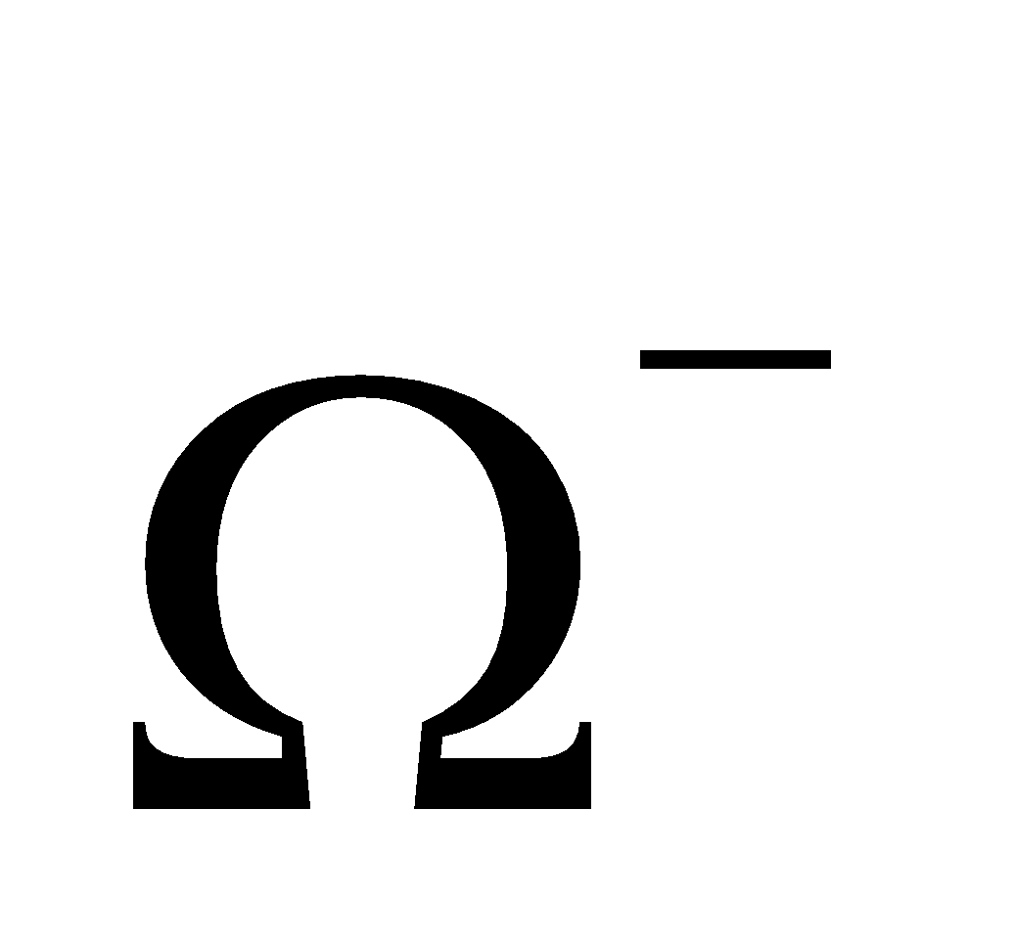 was confirmed experimentally and he received the Nobel Prize in 1969 for his work on sub-atomic particles.

**28. Interpret** We are to determine if the two given particles are each other’s antiparticles.

**Develop** In particle-antiparticle annihilation, baryon number must be conserved, and Table 39.1 tells us that both the 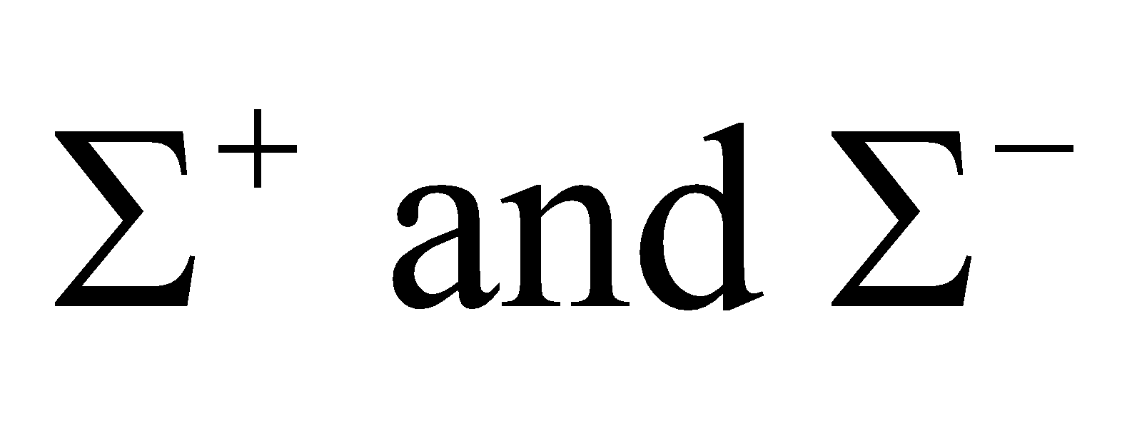 particles have baryon number 1, which makes this reaction impossible.

**Evaluate** Thus, these two particles are not each other’s antiparticles.

**Assess** The antiparticles are 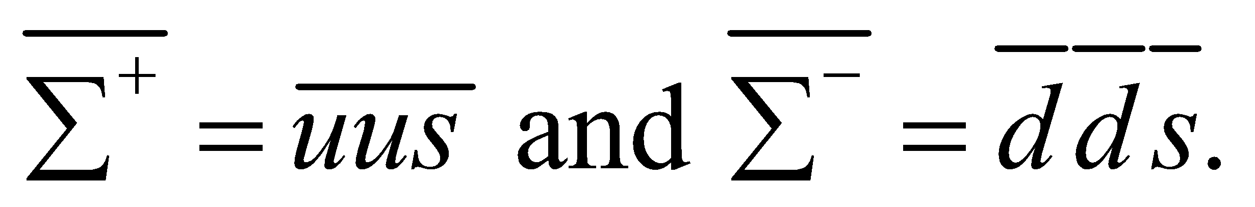

**Section 39.4 Unification**

**29. Interpret** The Kamiokande experiment uses 50,000 tons of water and is designed to detect rare nuclear reactions such as neutrino interactions and hypothetical proton decays. We want to estimate the volume of the water.

**Develop** The mass of 50,000 tons of water is (see Appendix C for the conversion factors)



The volume is 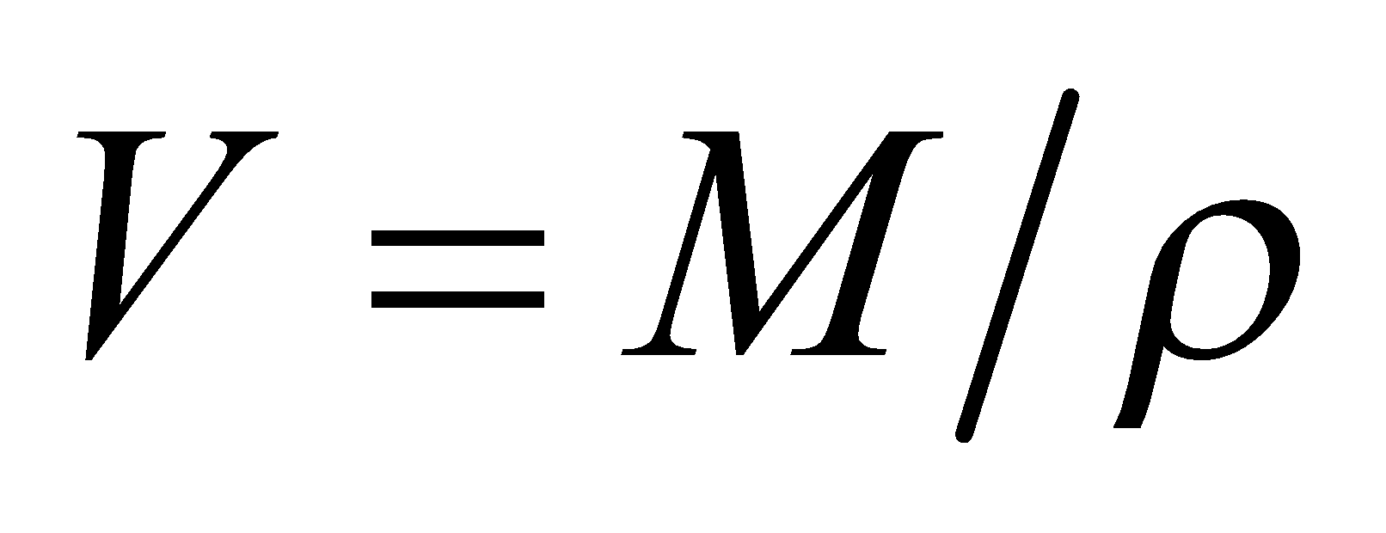 where *ρ* is the density of water.

**Evaluate** At the ordinary density of *ρ* = 1.00 × 103 kg/m3, this amount of water occupies a volume of

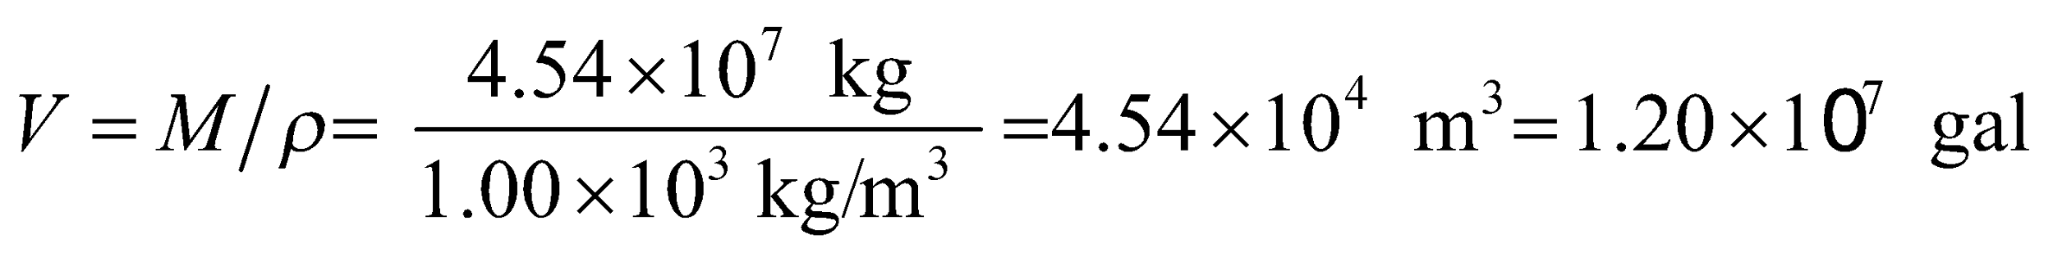

**Assess** This is the volume of a cube of side length

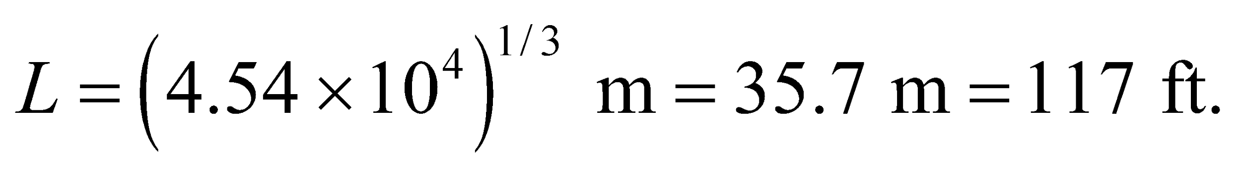

**30. Interpret** We are to estimate the temperature needed to make the electromagnetic force and the weak force appear to be a single phenomenon.

**Develop** Electromagnetic and weak forces are unified at particle energies above 100 GeV (see subsection on symmetry breaking). The temperature that corresponds to this is given by

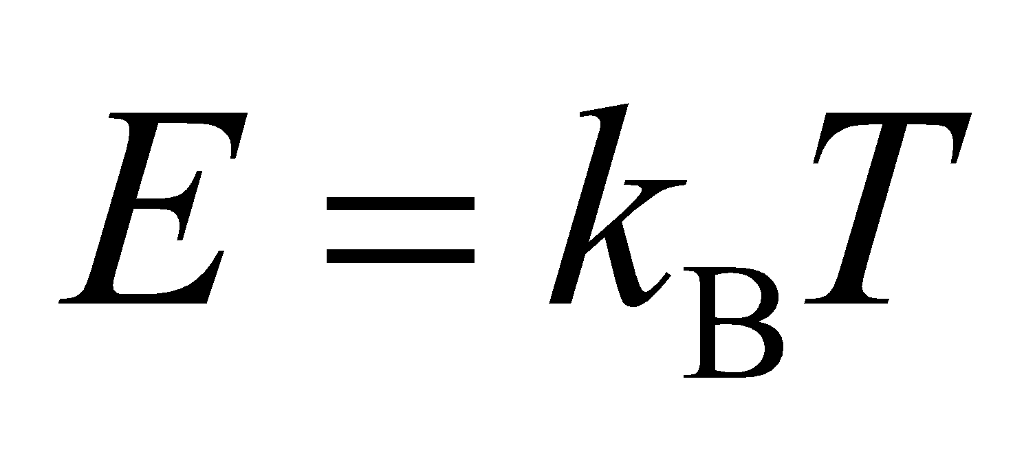

where *E* = 100 GeV and *k*B = 1.38 × 10−23 J/K is Boltzmann’s constant (see Equation 17.1).

**Evaluate** Using the expression above, 100 GeV corresponds to temperatures above

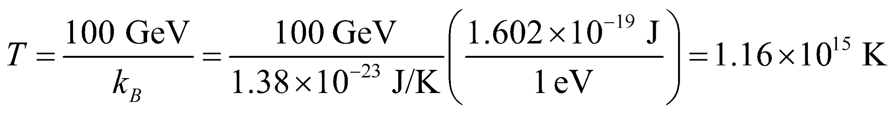

**Assess** This is much hotter than the core of the Sun, which is around 1.36 × 107 K.

**31. Interpret** In this problem we want to estimate the temperature in a gas of particles such that the thermal energy is about 1015 GeV; the energy of grand unification.

**Develop** The temperature corresponding to the energy where the strong and electro-weak forces unify is given by 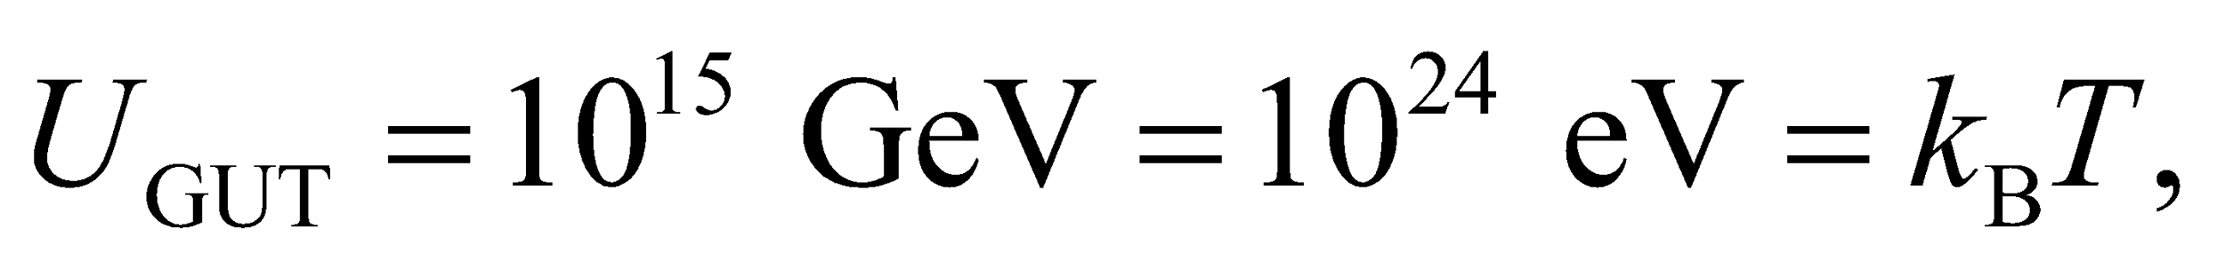 where 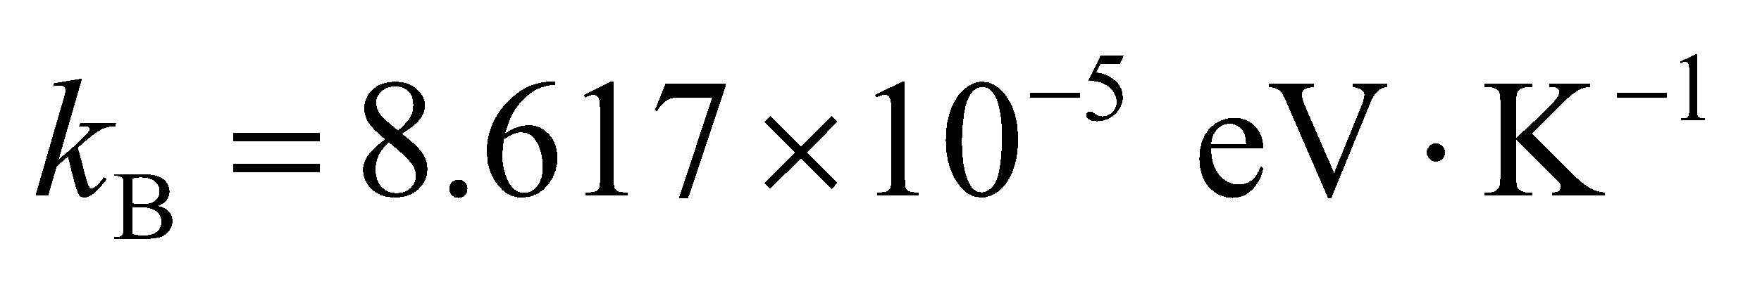 is Boltzmann’s constant.

**Evaluate** The temperature is

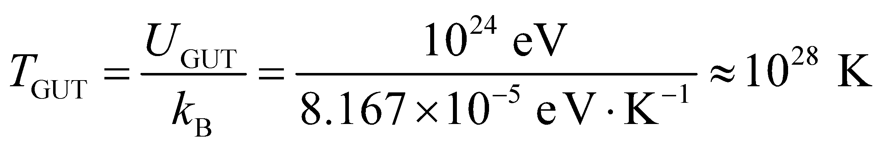

**Assess** This is an extremely high temperature! According to the inflationary Big Bang Theory, at about 10−35 s after the Big Bang, the grand-unified interaction breaks up into strong and electro-weak interactions.

**Section 39.5 The Evolving Universe**

**32. Interpret** The problem asks for the Hubble constant in SI units.

**Develop** The Hubble constant relates the recession speed of a galaxy to its distance from us: 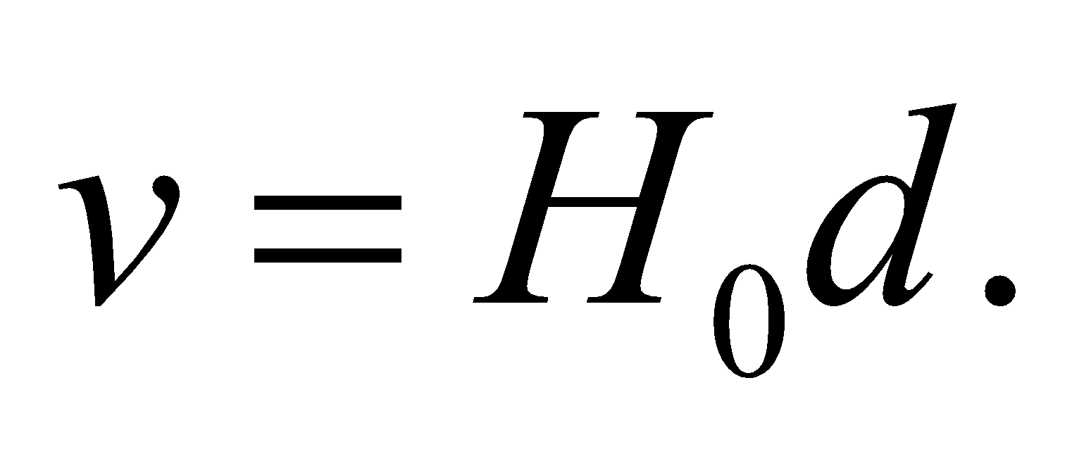 The current best value is 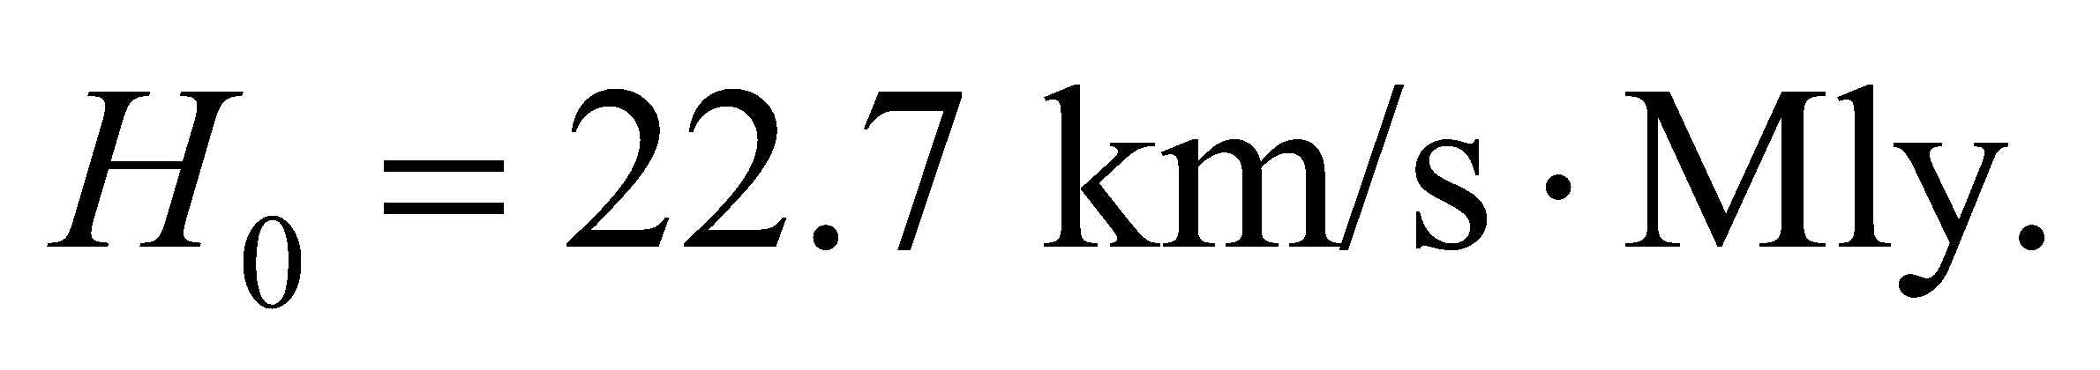

**Evaluate** To change to SI units, we use the conversion 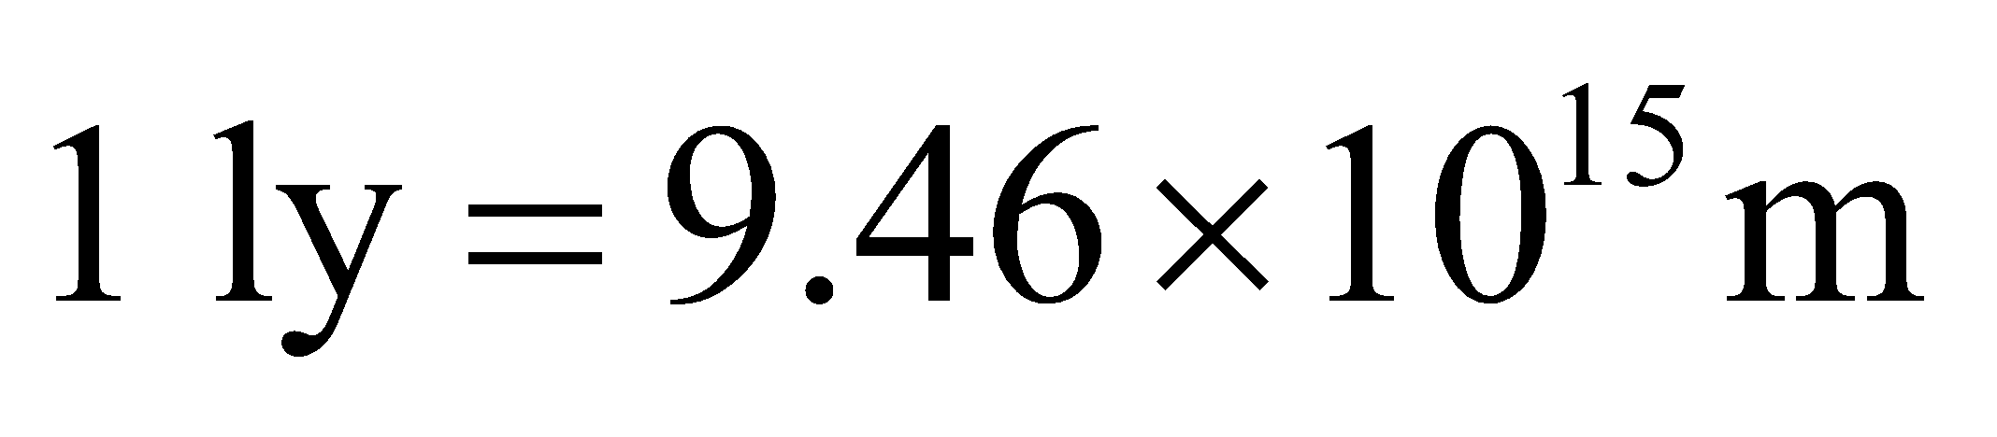 to obtain

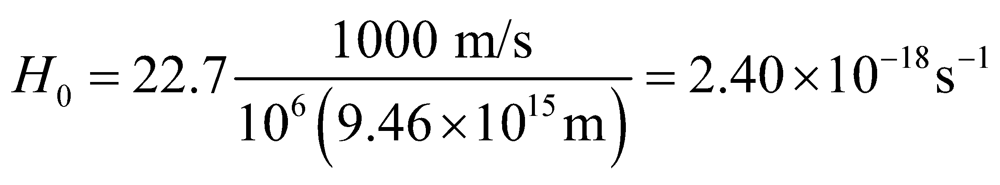

**Assess** As was explained in Example 39.2, the inverse of the Hubble constant (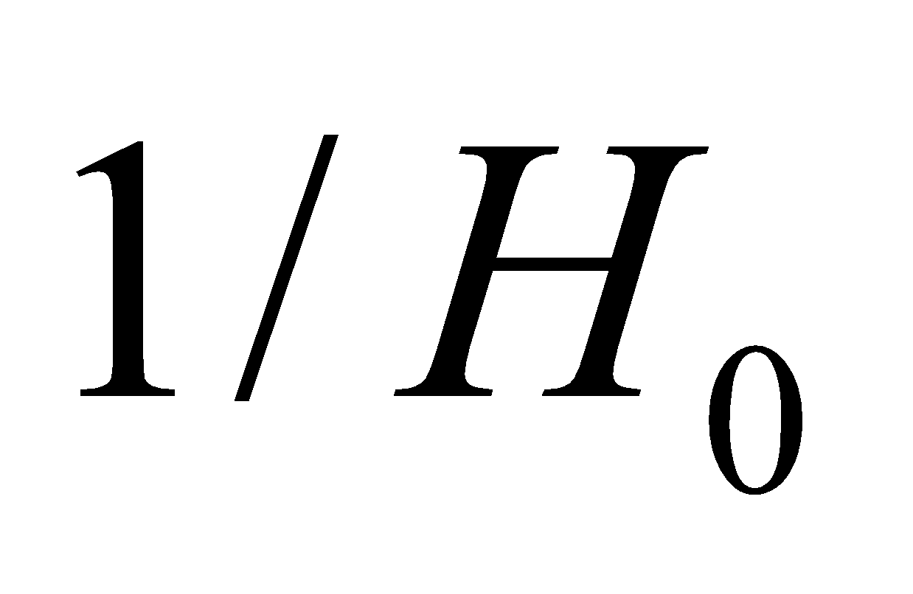) is a rough estimate for the age of the universe. The Hubble constant is often written in terms of parsecs 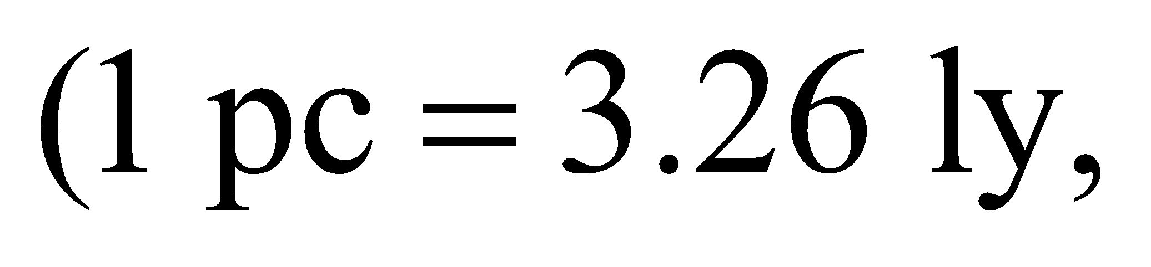 see Appendix D), in which case 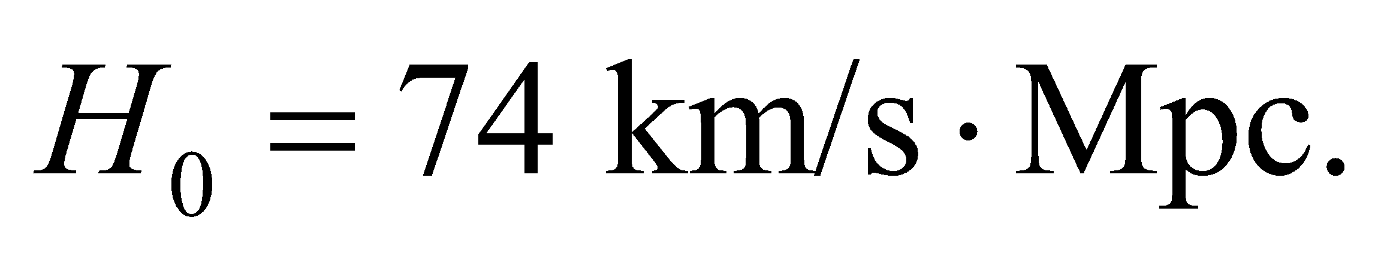

**33. Interpret** We use Hubble's law to calculate the distance to a galaxy that is receding at a given speed.

**Develop** Inverting Hubble's law (Equation 39.1) gives the distance in terms of the speed: 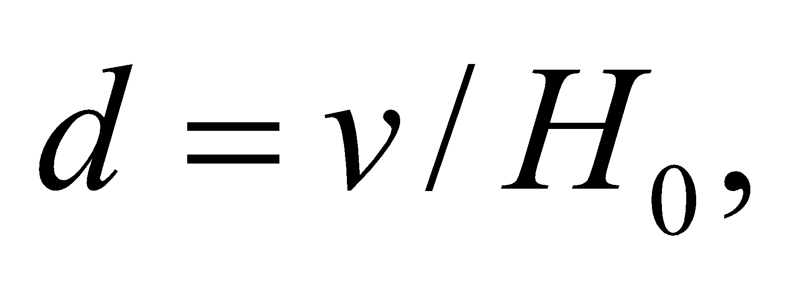 where the Hubble constant is 

**Evaluate** For a recession speed of 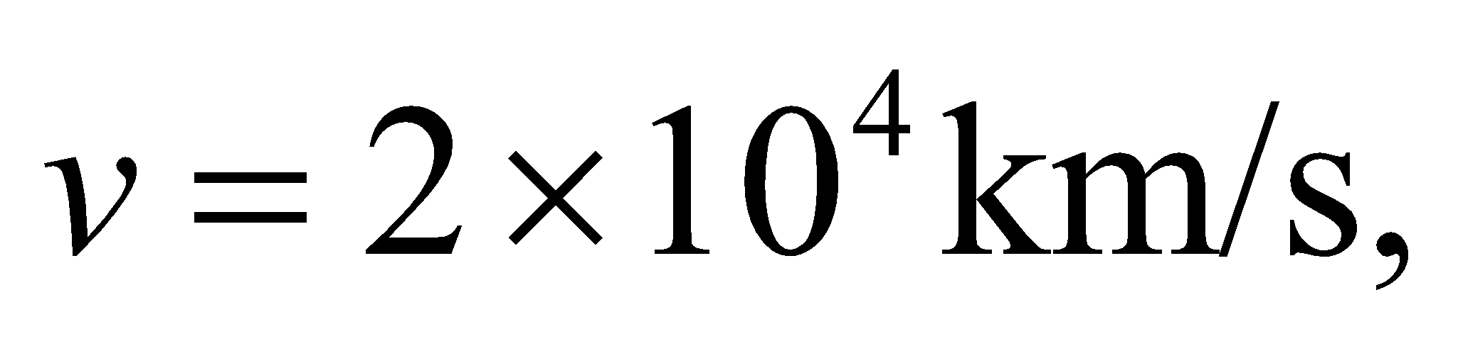the distance in light years is:

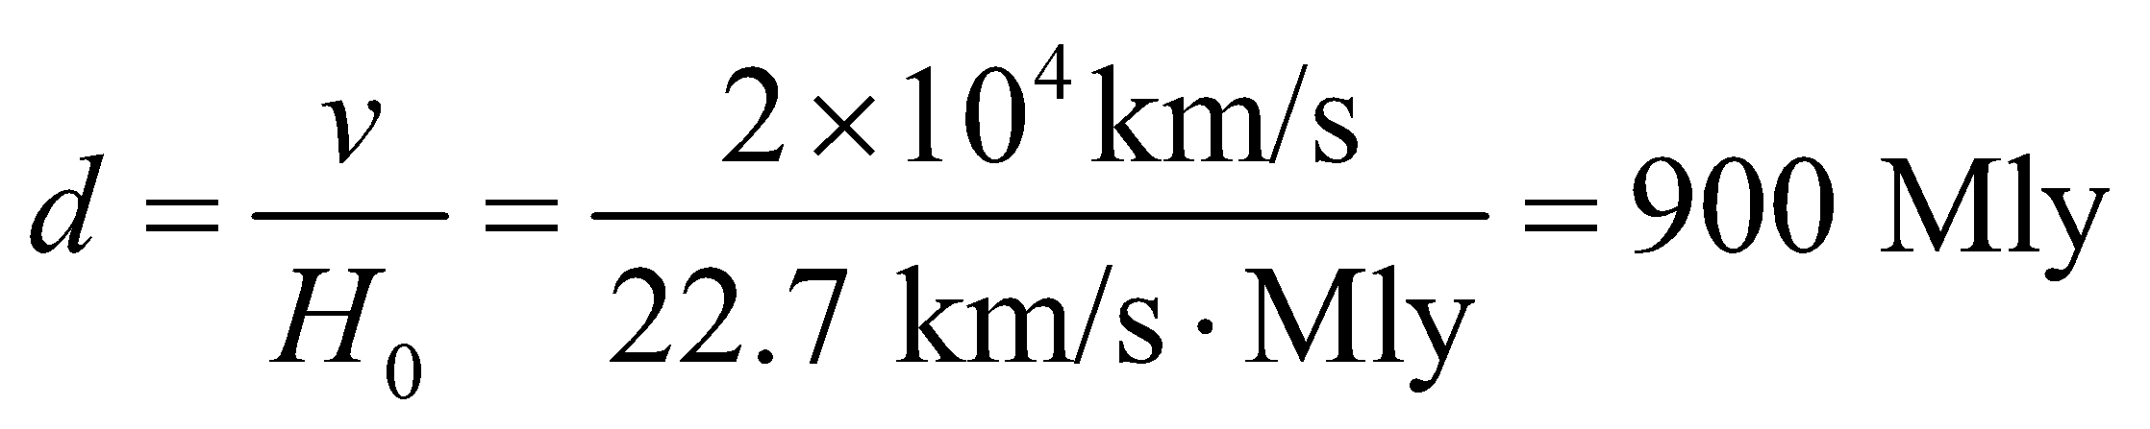

**Assess** The light that we are receiving from this galaxy left it 900 million years ago. When astronomers study galaxies at such distances, they are really studying what the universe was like millions of years ago.

**34. Interpret** We use Hubble’s law to calculate the recession speed of a distant galaxy.

**Develop** Hubble’s law is 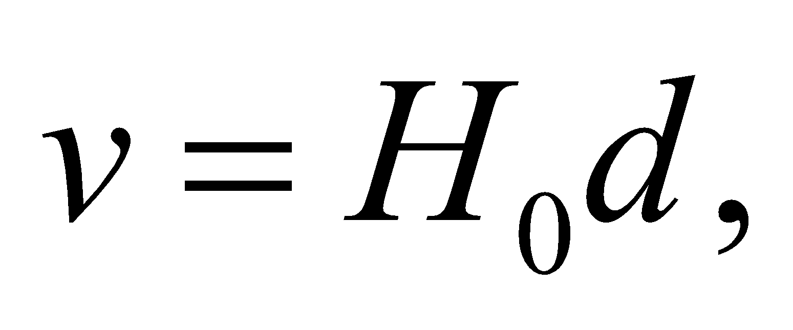 where the Hubble constant is 

**Evaluate** At a distance of 300 Mly, a galaxy will be receding from us at



**Assess** Amazingly, this is 2% of the speed of light, and there are many galaxies moving even faster than this. However, as the textbook mentions, it is perhaps better to think of this as a stretching of space, and the galaxies are merely being carried along.

**35. Interpret** We are asked to find the age of the universe based on a given Hubble constant.

**Develop** As discussed in Example 39.2, the age of the universe is given by 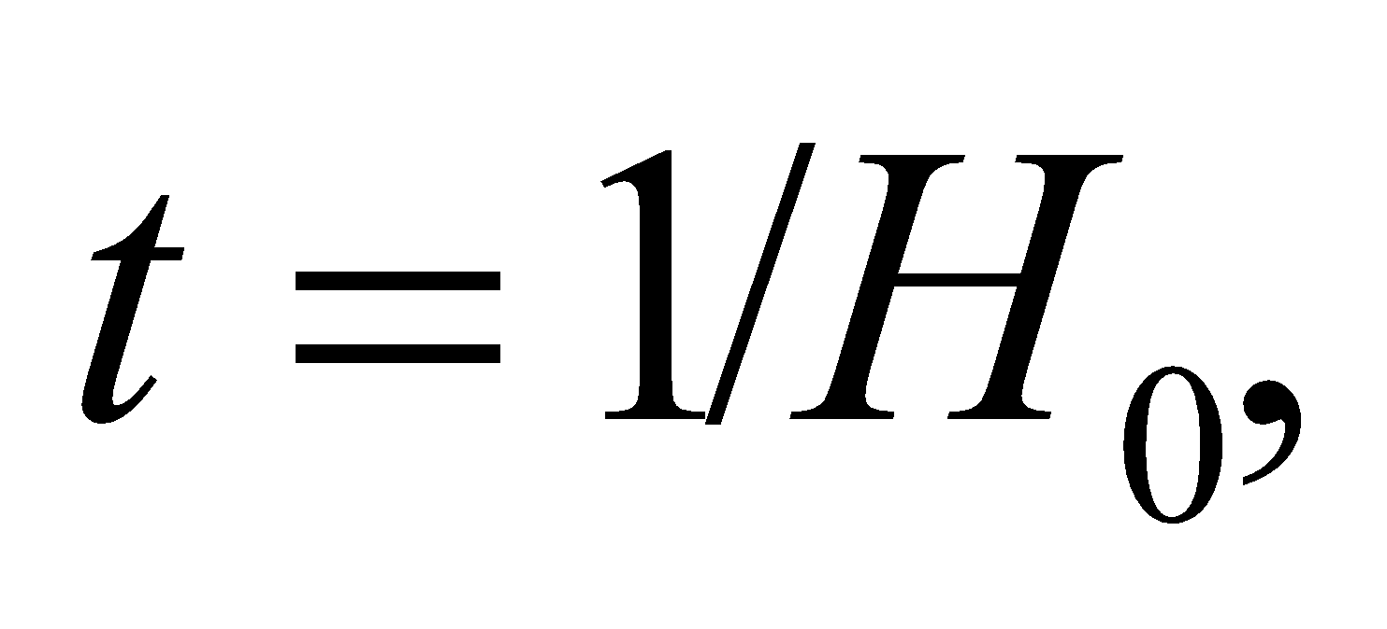 where 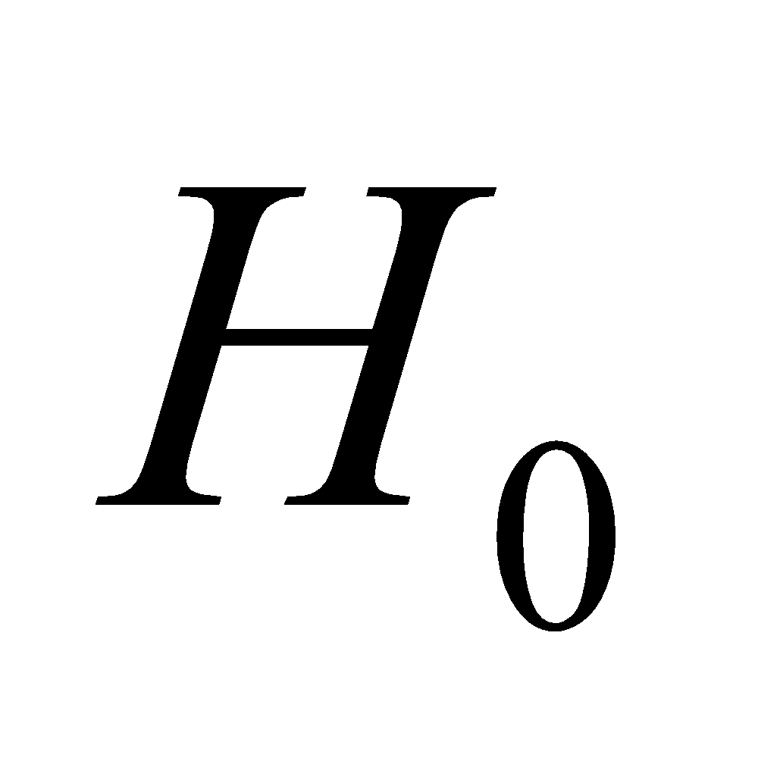 is the Hubble constant.

**Evaluate** With 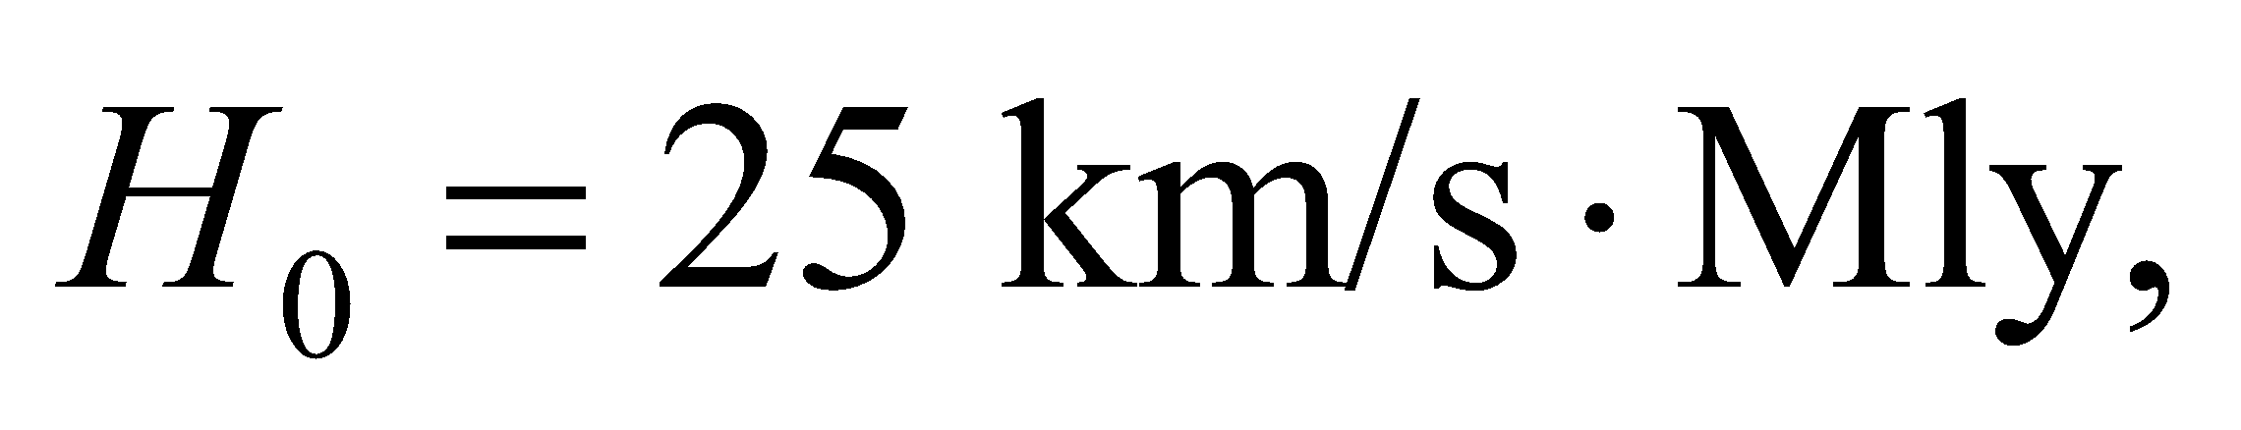the age of the universe would be

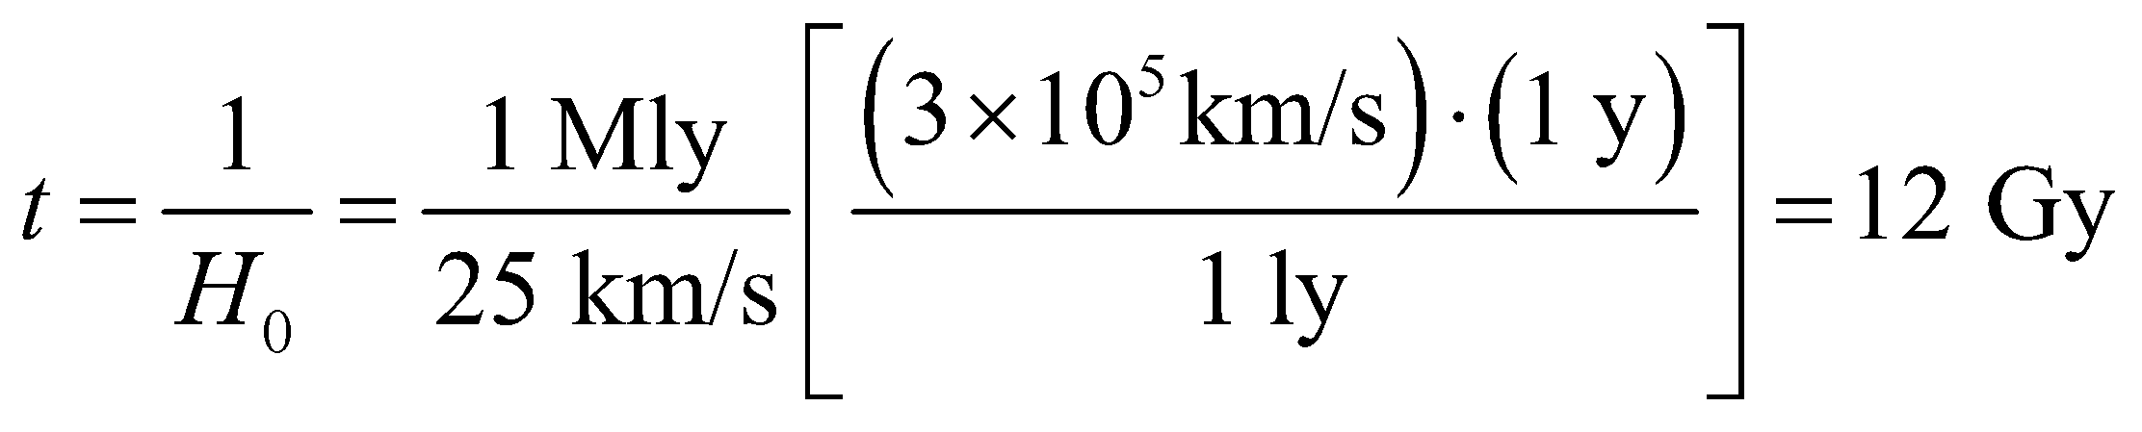

**Assess** Note that we used the definition of a light year as the distance that light travels in one year.

**Problems**

**36. Interpret** We are to find the range of the electromagnetic force if the photon had the given mass instead of zero mass.

**Develop** According to the version of Yukawa’s argument in the text, the relation between the mass of a field particle and the range of the force it mediates is

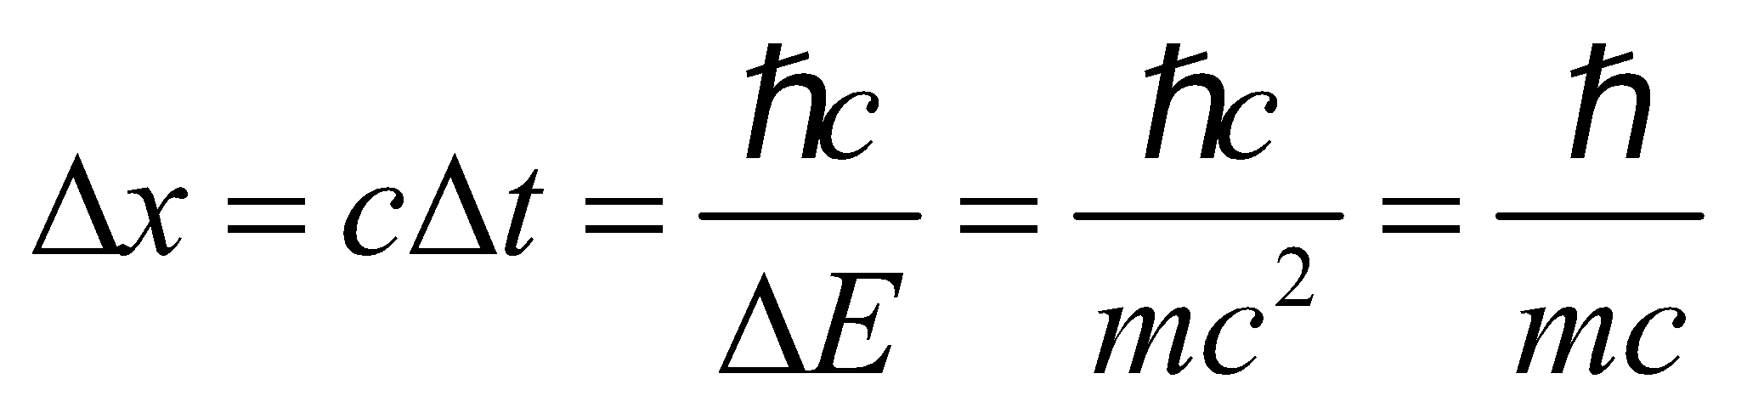

(i.e., the range of the force is approximately the Compton wavelength of the mediating field particle).

**Evaluate** For *m* = 5× 10−63 kg, the range of the electromagnetic force would be

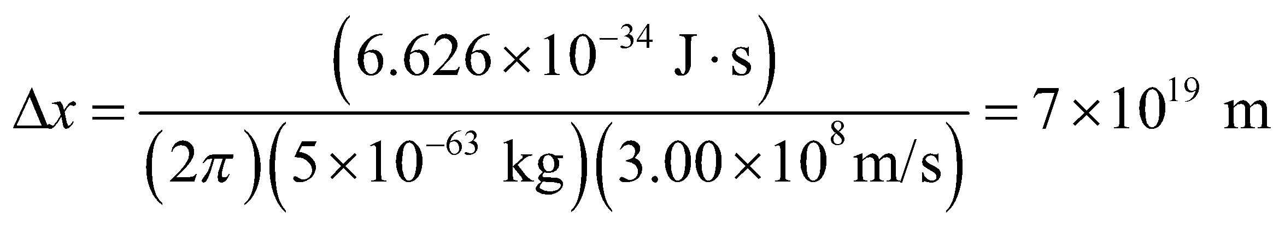

**Assess** This is less than a tenth the diameter of our galaxy (see Table 1.2).

**37. Interpret** We are asked to apply conservation laws to decide whether or not the given interactions are possible.

**Develop** The relevant properties to be considered here are charge, baryon number, and spin (see Table 39.1).

**Evaluate** **(a)** The decay, 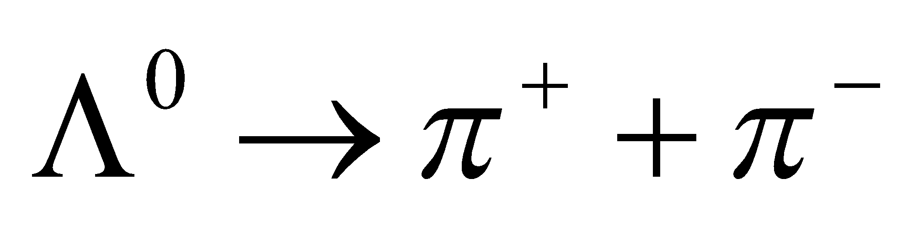 conserves charge [0 = 1 + (−1)], but violates conservation of baryon number 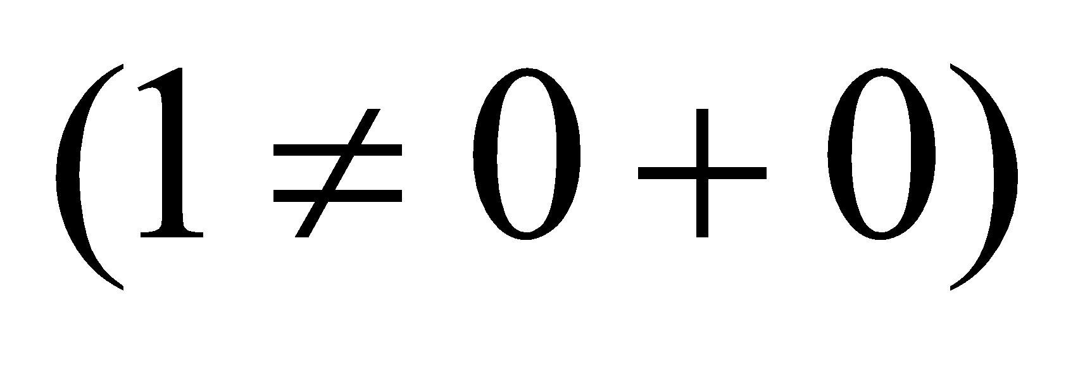 and angular momentum because the spin of 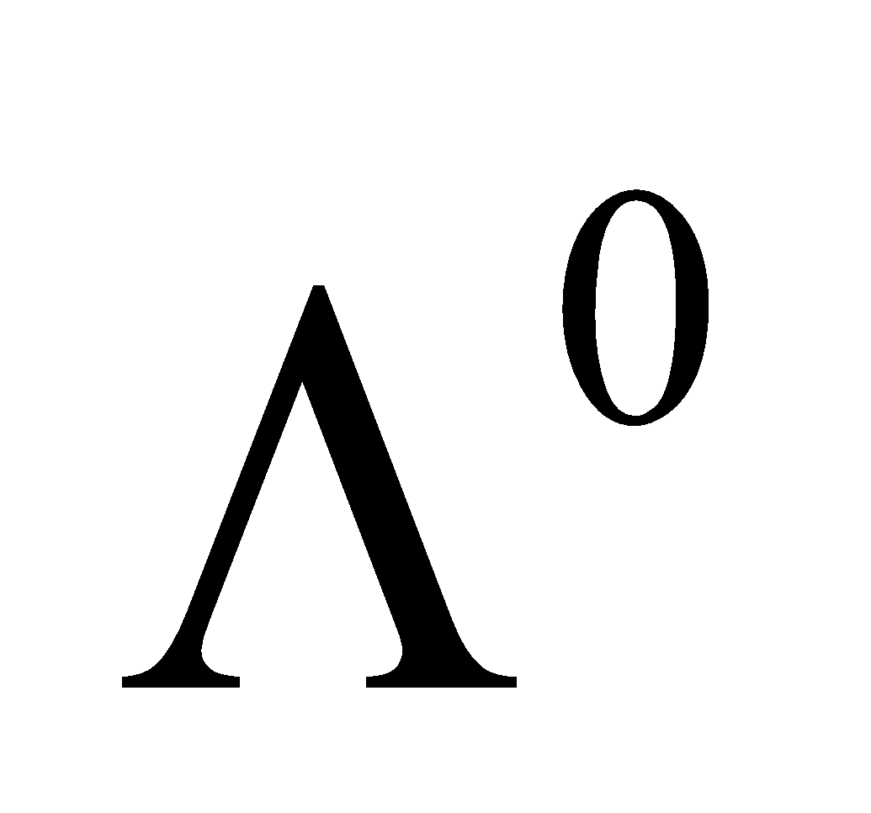 is  and the spin of each pion is 0. Thus, this reaction is not allowed.

**(b)** The decay 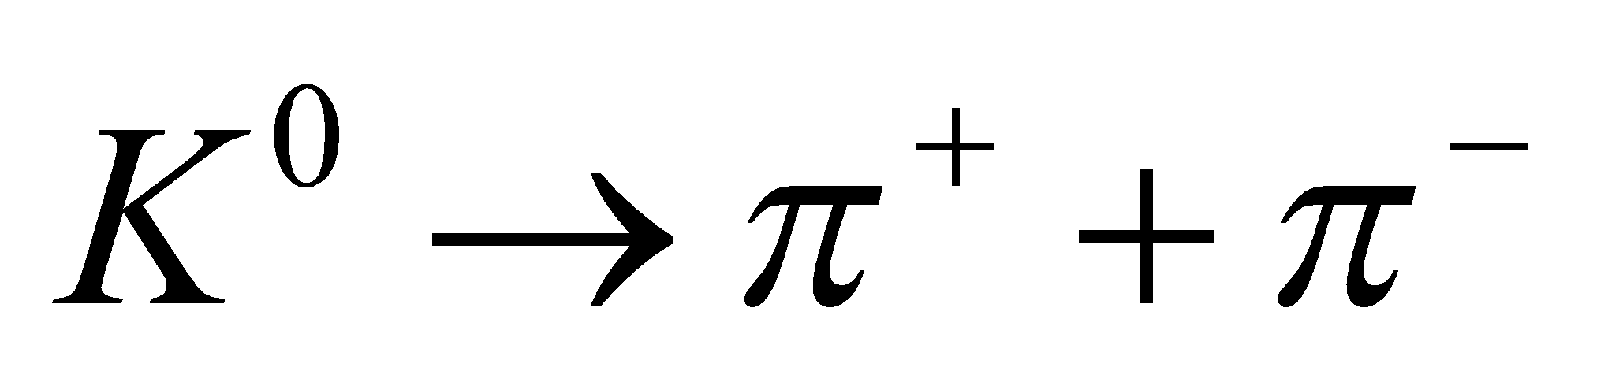 conserves angular momentum (at zero), charge (at zero), and lepton number (at zero), but does not conserve strangeness, which is 1 for the kaon and zero for each pion. However, strangeness is not conserved by the weak interaction, so this decay is possible.

**Assess**  The decay of part (b) is an observed weak interaction. This problem illustrates how conservation laws restrict the possible outcomes of particle interactions.

**38. Interpret** We are to determine which of the two given reactions is mediated by the weak force and explain our reasoning.

**Develop** A reaction in which a kaon decays to a pion violates conservation of strangeness (see Table 39.1). The decay of a *ρ* meson to a pion, however, does not.

**Evaluate** Because the weak interaction allows conservation of strangeness to be violated, it must mediate the reaction of the kaon to pion-antipion, but not *ρ* meson to pion-antipion.

**Assess** The weak interaction does not conserve strangeness, but does conserve angular momentum, lepton number, baryon number, and charge.

**39. Interpret** This problem is about the conservation laws in the hypothetical proton decay suggested by the grand unification theory. We are to find if baryon number and charge are conserved in this reaction.

**Develop** The relevant properties we wish to consider in the hypothetical decay 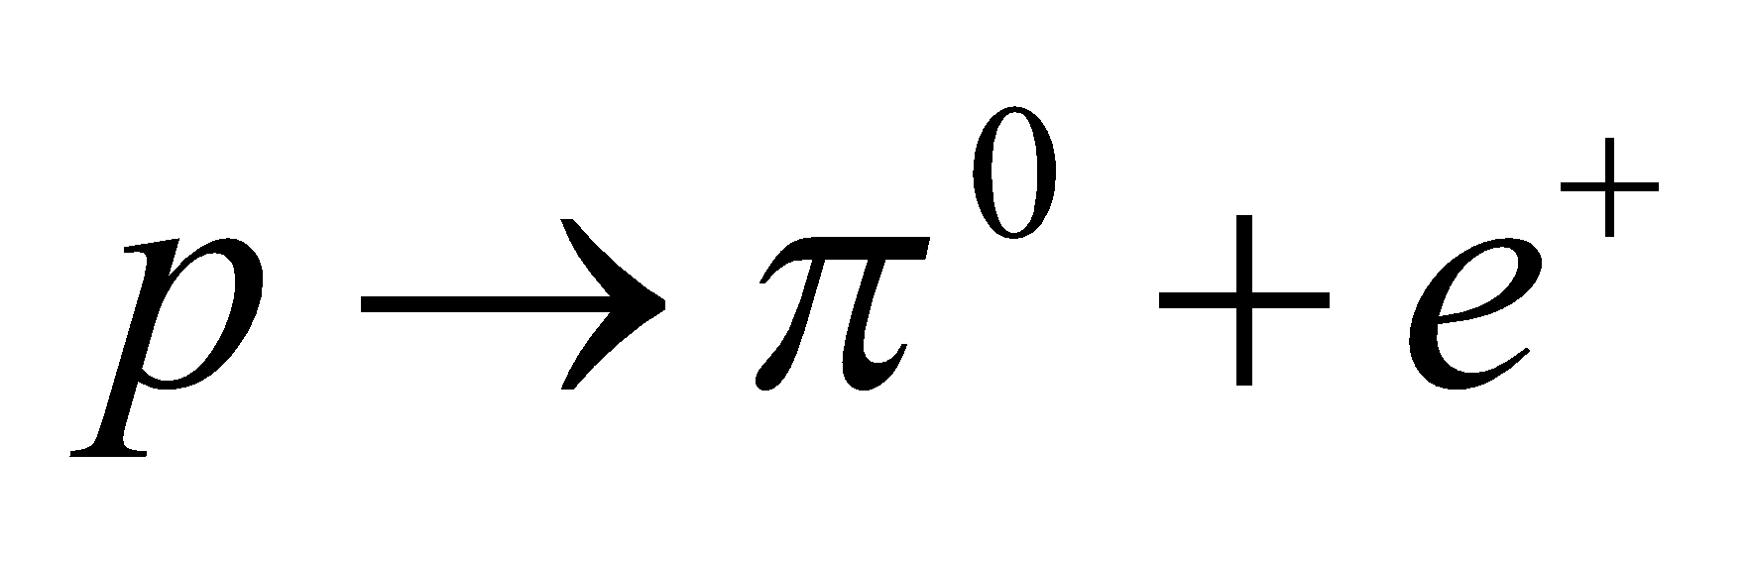 are charge and baryon number (given in Table 39.1).

**Evaluate** **(a)** The hypothetical decay  does not conserve baryon number (which is 1 for the proton and 0 for mesons and leptons), nor does it conserve lepton number.

**(b)** The hypothetical decay does conserve charge (1 = 0 + 1).

**Assess** Baryon number is conserved in the Standard Model but not in the Grand Unification Theory.

**40. Interpret** Given three wave functions, we are to find which pair may be transformed into themselves under a parity-conserving interaction.

**Develop** In a parity-conserving transformation, 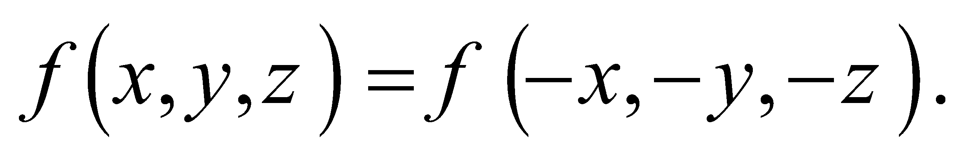

**Evaluate** For the terms given, **(a)** 

**(b)** **,** and

**(c)** **.**

The first two have parity +1 and the third has parity −1. In a parity-conserving reaction, systems described by terms **(a)** and **(b)** could transform into themselves under a parity-conserving interaction.

**Assess** Functions (a) and (b) are even, whereas function (c) is odd.

**41. Interpret** We are to determine the composition of the *J*/*ψ* particle, which includes charm quarks but has charm *c* = 0.

**Develop** The *J*/*ψ* particle is a meson. A meson is a particle that consists of one quark and one antiquark, so its baryon number is zero. A charmed quark **(***c***)** has charm c = +1, whereas an anticharmed quark 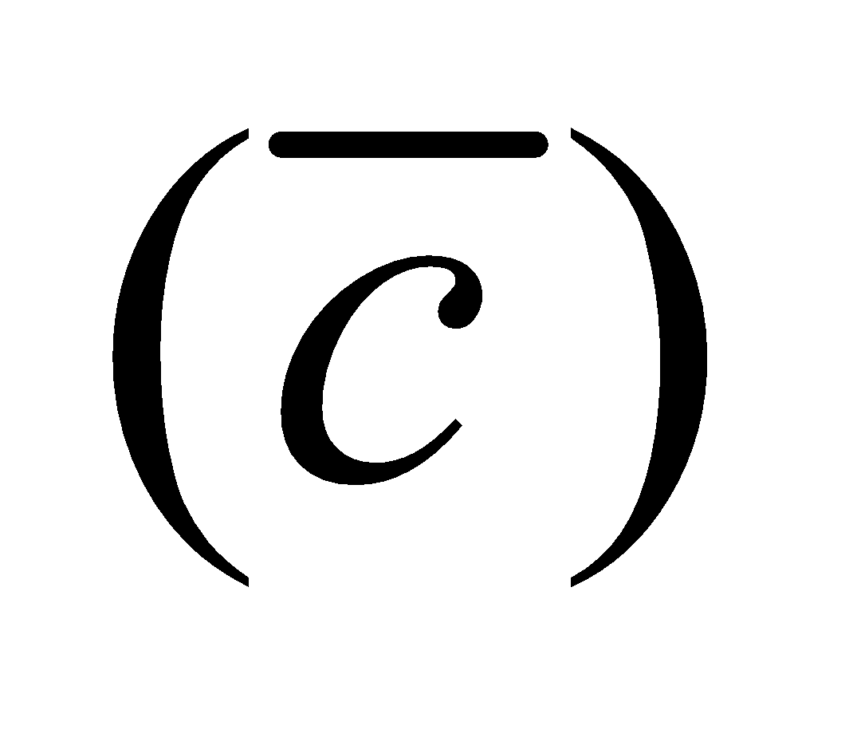 has *c* = −1.

**Evaluate** The *J*/*ψ* particle must have quark content 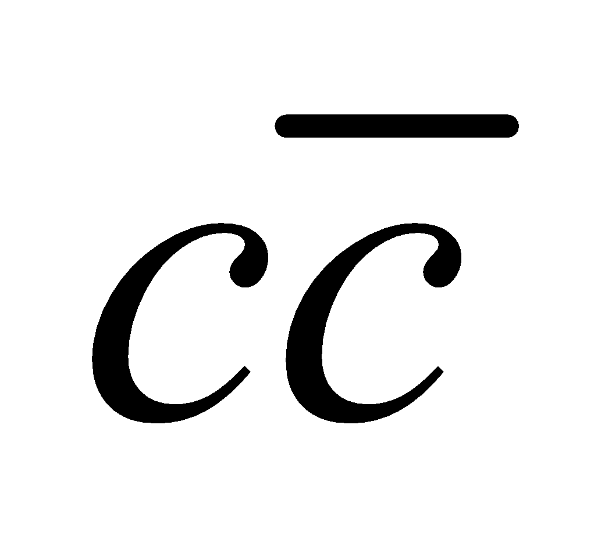 in order to have zero net charm.

**Assess** Charmed is one of the six flavors of quarks (up, down, strange, charmed, bottom, and top).

**42. Interpret** This is an exercise in quark composition. We are to list all possible quark triplets formed from up, down, and charmed quarks.

**Develop** There are three triplets with all the same type of quark, one triplet with all different quarks, and 3 × 2 = 6 triplets with two quarks of the same type, making a total of 10 combinations.

**Evaluate** These are tabulated below, with the charge of each (the sum of the quark charges) and some examples.

| **State** | **Charge** | **Example** |
| --- | --- | --- |
|  |  |  |
|  |  |  |
|  |  |  |

**Assess** The order in which the quarks are listed does not matter (i.e., *udd* = *dud* = *ddu*).

**43. Interpret** This problem explores some properties of the Tevatron accelerator at Fermilab.

**Develop** The conversion from eV to J can be done by noting that one TeV is equal to 1012 eV and 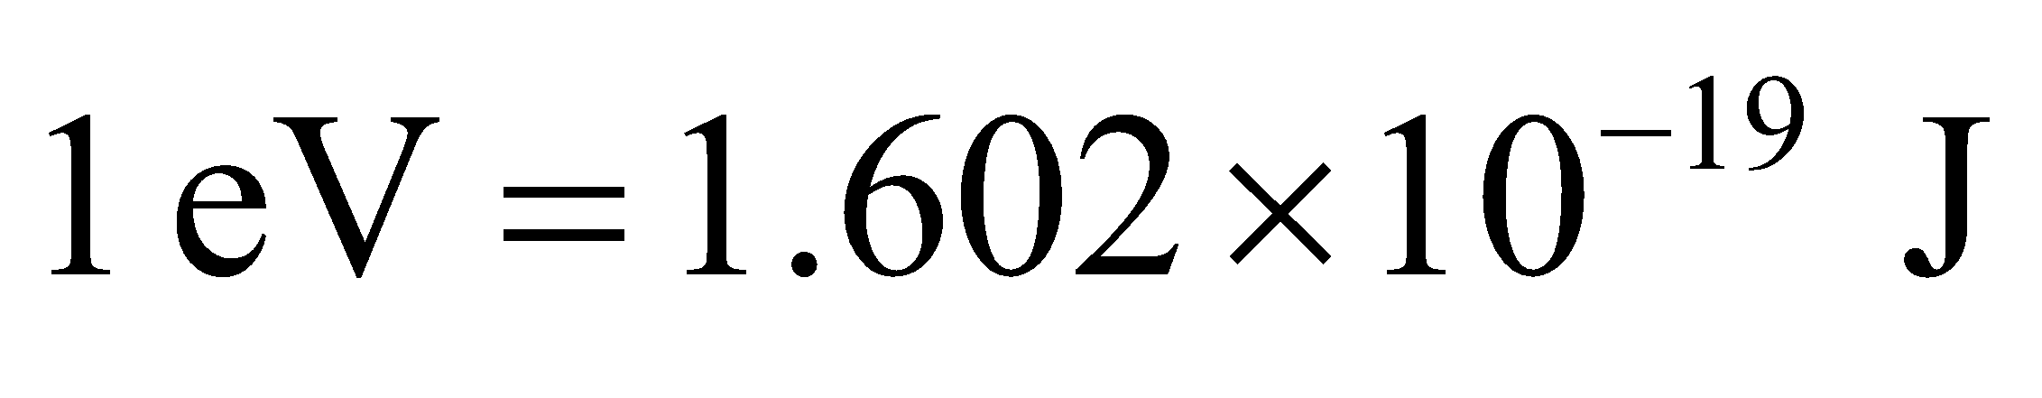 (see Appendix C). To answer part (b), note that the energy of a particle of mass *m* falling a distance *y* in Earth’s gravitational field is *U* = *mg*Δ*y* (see Equation 7.3).

**Evaluate** **(a)** 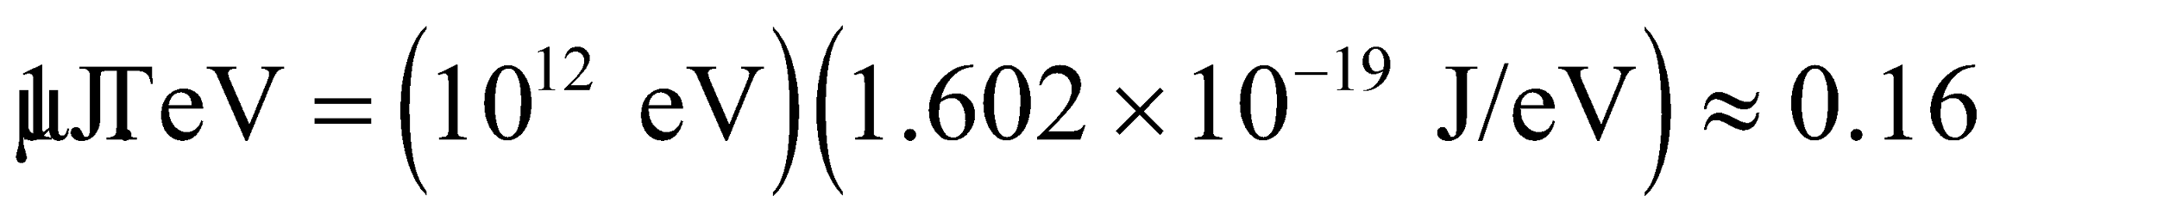

**(b)** Setting 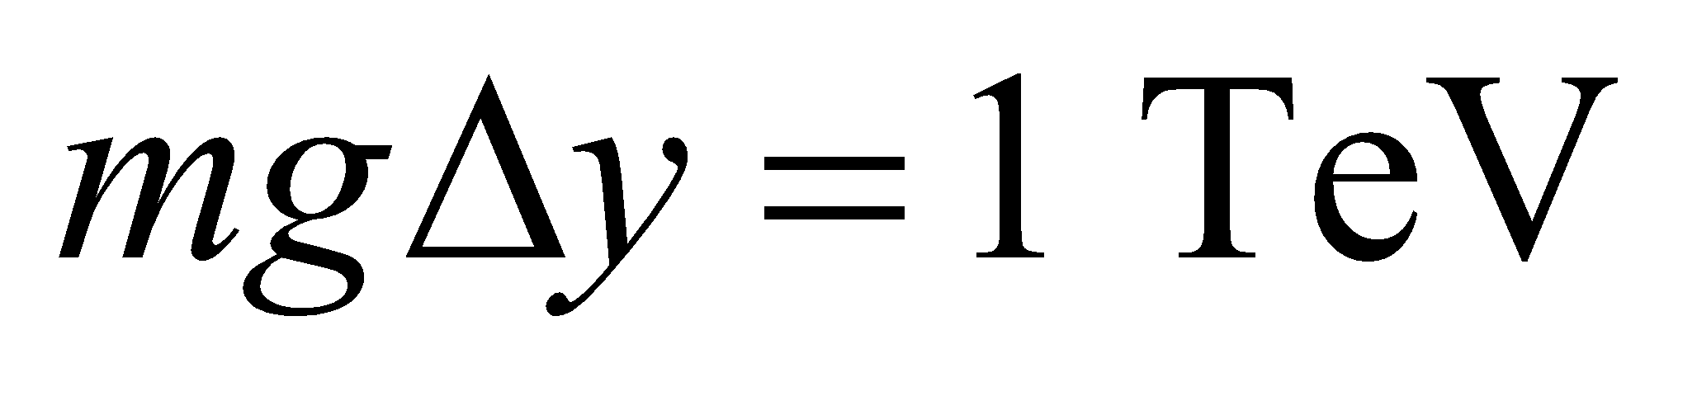 with *m* = 1 g, the height from which the mass must drop is

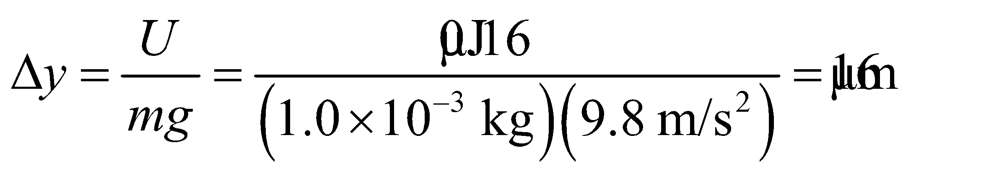

**Assess** This is a very small height, but remember that 1 g of protons contains about 6 × 1023 particles, whereas each proton in the Tevatron beam has this energy.

**44. Interpret** We are to find the relativistic factor *γ* (see Table 33.1) for a 7-TeV proton and find its speed.

**Develop** The relativistic factor *γ* is given by

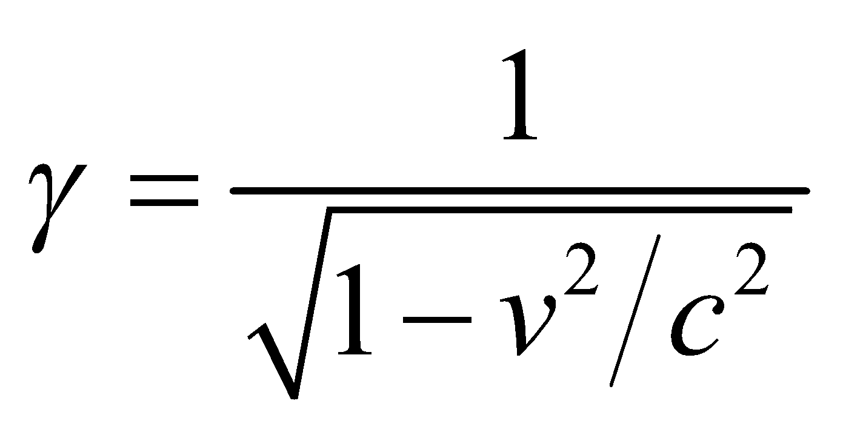

(see Chapter 33). A proton’s rest energy (i.e., *m*p*c*2) is 938 MeV, which is much less than its kinetic energy of 7 TeV. We can therefore neglect the former with respect to the latter and write

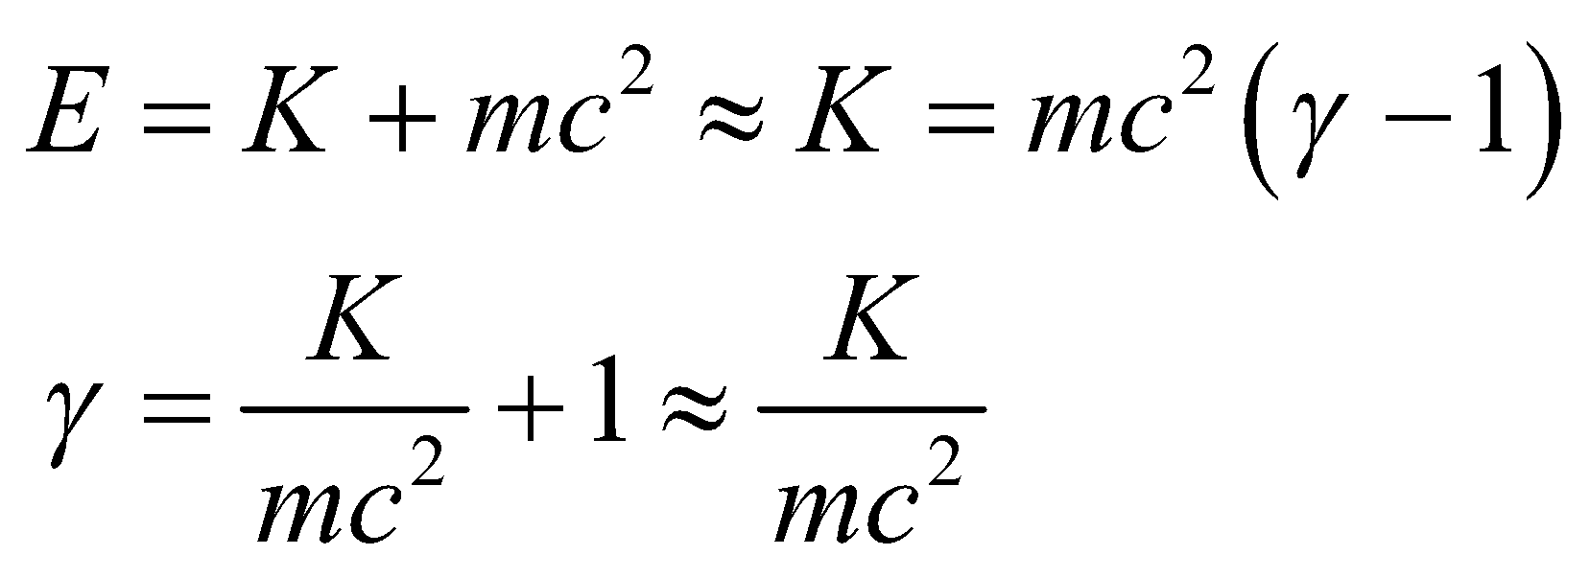

where we have used Equations 33.9 and 33.8.

**Evaluate** **(a)** Inserting K = 7 TeV, we find



**(b)** For so large a *γ*, *v*/*c* is very close to unity, so we can expand the radical in the expression for *γ*:

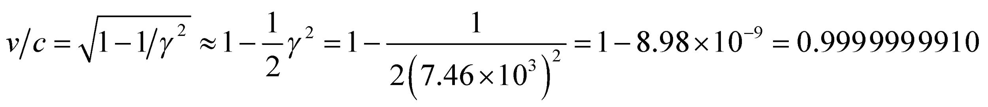

**Assess** To the precision allowed by the data (a single significant figure), *v*/*c* = 1.

**45. Interpret** We want to estimate the time it takes for a 7-TeV proton to travel a circular path with a circumference of 27 km.

**Develop** With a kinetic energy *K* = 7 TeV, the speed of a proton  is very close to the speed of light (see preceding problem). Thus, the time in the lab frame that it takes to complete one circuit is given by *t* = *d*/*c*, where *d* = 27 km.

**Evaluate** Using *c* = 3.0 × 105 km/s, the time required to travel 27 km is

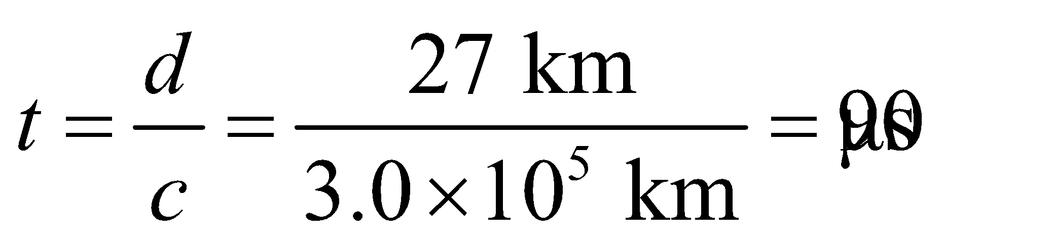

**Assess** Light travels about 3 × 105 km in one second. Since the speed of the proton is so close to the speed of light, the time it takes to travel 27 km is very short. In the proton’s frame, the time *t*′ it takes to travel the distance is

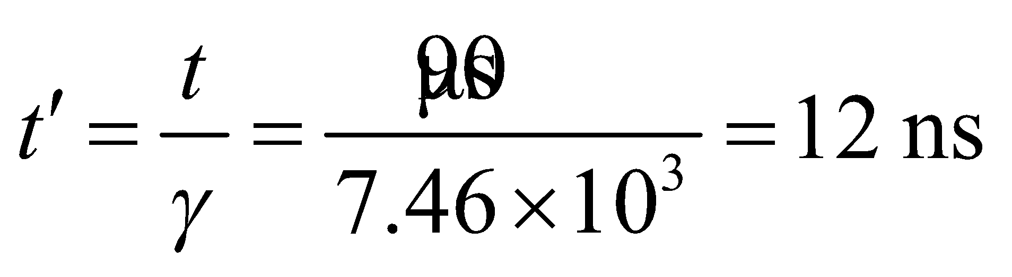

(see Equation 33.3).

**46. Interpret** We are to estimate the critical density of the universe, for which we shall use Equation 39.2.

**Develop** Apply Equation 39.2,



where *H*0 = 22.7 km·s−1·Mly−1 is the Hubble constant (see Equation 39.1) and *G* = 6.67× 10−11 N·m2·kg−2 is the constant of universal gravitation (see Equation 8.1).

**Evaluate** Inserting the given values yields

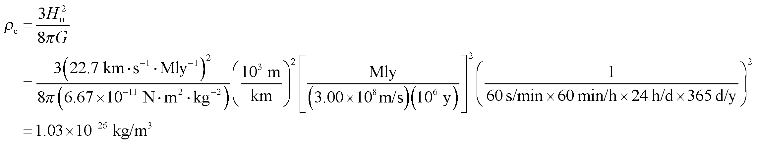

**Assess** This works out to about 10 nucleons per cubic meter. Not very dense at all!

**47. Interpret** We are to estimate the diameter of the Sun if it had the same density as the critical density of the universe. We will assume that the mass of the Sun is the same, and use the value for *ρ*c obtained in the Problem 39.46.

**Develop** The mass of the Sun is M = 1.99 ×1030 kg (see Appendix E) and the critical density (from Problem 39.44) is



The volume of a sphere is  and  We shall solve for *r*.

**Evaluate**



**Assess** The universe is really not a very dense place at all. It’s only dense in small, very widely separated regions such as planets, solar systems, galaxies, and so on.

**48. Interpret** We are to find the speed at which we must collide protons to form the lambda–antilambda particle pair. The energy of the reactants must be sufficient to produce this particle pair.

**Develop** There must be enough mass-energy in the 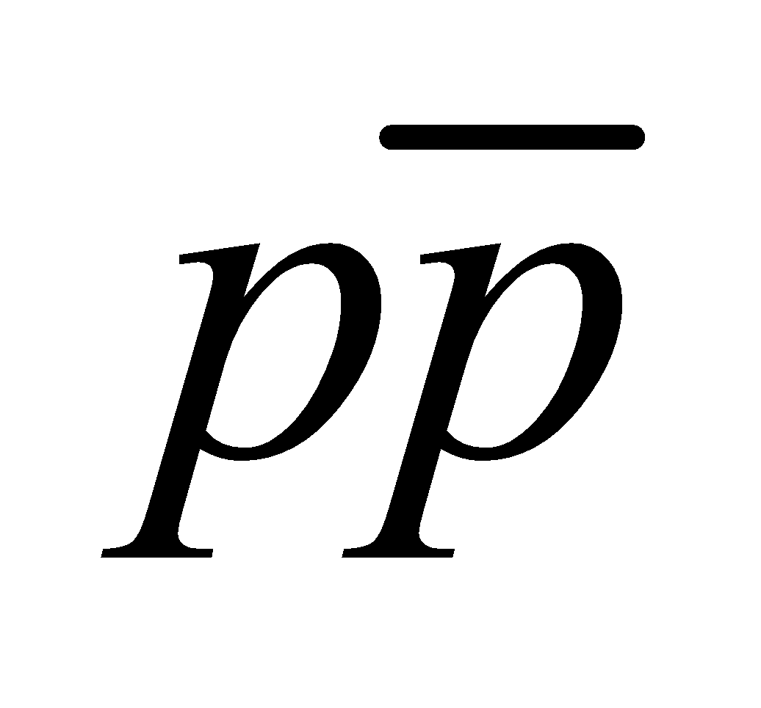 center-of-mass system to produce a 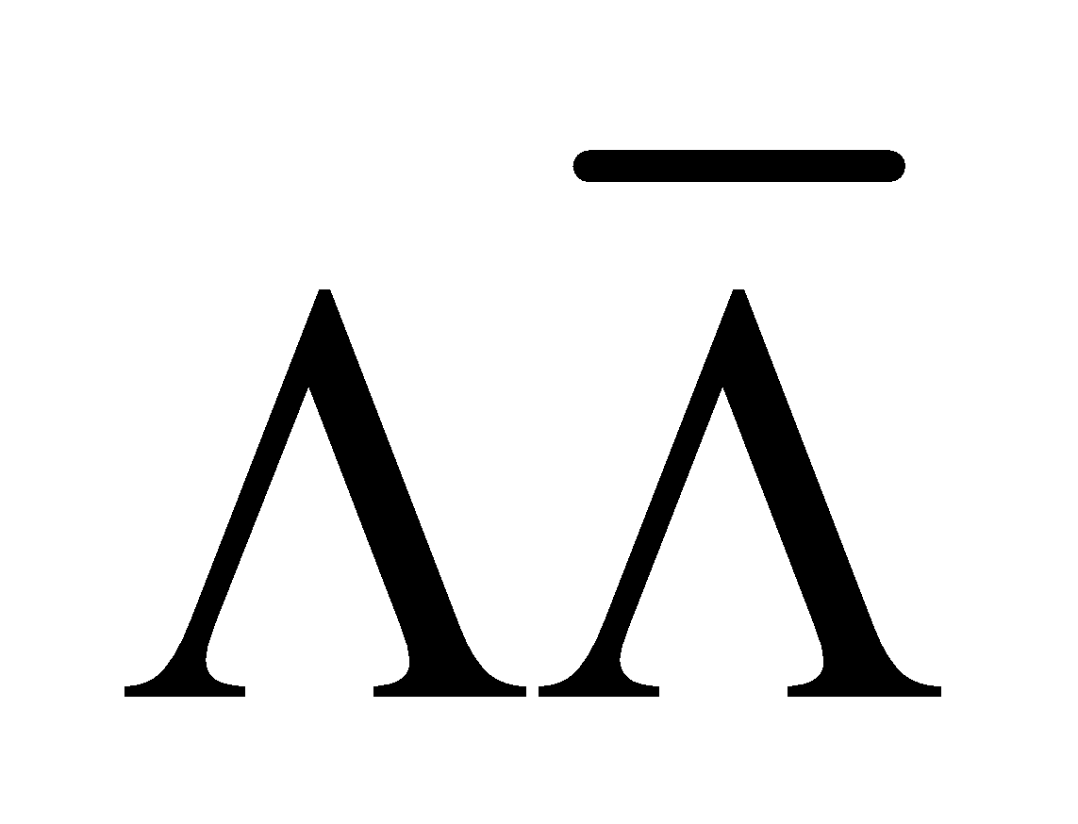 pair. In a colliding beam experiment, a proton and antiproton each with mass-energy  collide head-on, thus all the energy is available in the center-of-mass system. In this case,  or



Knowing g allows us to find the speed and therefore the kinetic energy (using the relativistic expression Equation 33.8).

**Evaluate** This corresponds to a speed of , or *v* = 1.63 × 108 m/s, and to a kinetic energy of 

**Assess** Production of  pairs has recently been reported in  collisions at 1.8 TeV at the Fermilab Collider. Although energetically permitted, the probability of  production near the energy threshold is vanishingly small.

**49. Interpret** In this problem we want to find the size and the ground-state energy of a muonic atom, which consists of a proton at the nucleus and a muon in the place of the electron.

**Develop** We can use the results for the Bohr atom, with  replacing *m*e (see Equations 34.12a and 34.13). Thus, the radius of the muonic atom is

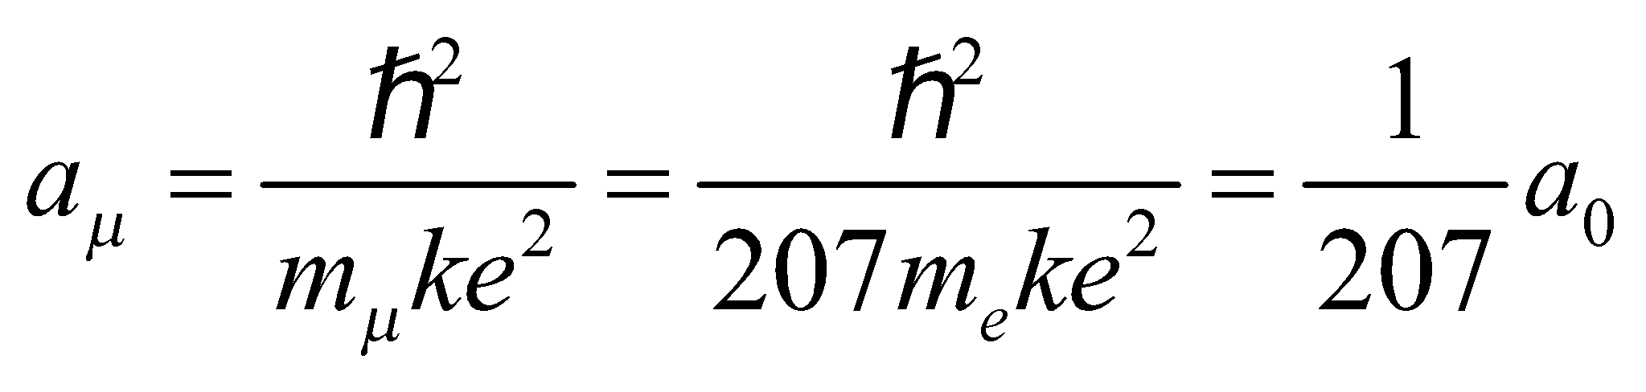

and its ground-state energy is



where *a*0 and *En* are the Bohr radius and ground-state energy of the hydrogen atom, respectively.

**Evaluate** **(a)** For the ground state (*n* = 1),



**(b)** The ground-state energy is 

**Assess** The size of the muonic atom is reduced by a factor of 207 with respect to the hydrogen atom, and its ground-state energy is increased (i.e., more negative) by the same factor of 207.

**50. Interpret** This problem involves calculating various parameters of a proton synchrotron, in which the protons travel at relativistic speeds.

**Develop** Protons are bent by the synchrotron’s magnetic field into a circle of radius *r* given by Equation 26.3. This equation actually applies to relativistic velocities if it is written in the form *p* = *qBr*, where  is interpreted as the proton’s relativistic momentum. We can then use the equations in Section 33.8 () to express the product of magnetic field and radius in terms of the proton’s kinetic energy,



Thus, to increase *K* by 10, requires *Br* to increase by:



for .

**Evaluate** This ratio is the same, whether **(a)** *B* is increased for fixed *r*, or **(b)** vice versa. In both cases, the result is 10 for highly relativistic protons (i.e., ).

**Assess** The numerical value depends on the proton’s energy, but is approximately 10, for the extreme relativistic energies of today’s accelerators 

**51. Interpret** The problem involves finding a galaxy's recession speed from the wavelength shift in one of its emission lines.

**Develop** We have a moving source (the galaxy) that is receding from us the observer, so we use Equation 14.14b for the Doppler shift:



where *u* in this case is the recession speed of the galaxy, and is the speed of the electromagnetic waves that we are receiving. We are told that the hydrogen-β spectral line  is shifted to 

**Evaluate**  (a) Solving for the recession speed, we find



(b) Plugging this speed into the Hubble law, we find



**Assess** The speed in part (a) is less than 2% of the speed of light, so we are justified in using the nonrelativistic Doppler formula.

**52. Interpret** We are to find the median wavelength and the photon energy of the cosmic background radiation when the universe cooled to transparency (i.e., at about 3000 K). We will use Equation 34.2b and the relationship between photon energy and wavelength.

**Develop** Apply Equation 34.2bto find the median wavelength and Equation 34.6  to find the photon energy.

**Evaluate** **(a)** Inserting the numerical values gives



**(b)** The photon energy is



**Assess** The characteristics of this light are about the same as for a low-wattage incandescent light bulb.

**53. Interpret** This problem explores using the width of the measured energy distribution of a particle to estimate its lifetime using the energy-time uncertainty principle.

**Develop** In the energy-time uncertainty relation (Equation 34.16), *Δt* = *τ* can be taken to be the lifetime of the particle (i.e., the time available for the measurement) and *ΔE* = Γ to be its width (i.e., the spread in measured rest energies). Thus,  (this is, in fact, the definition of the width).

**Evaluate** For the particle  a width  implies a lifetime



**Assess** These extremely short-lived particles are called “resonances.”

**54. Interpret** This problem considers a system that initially has an equal number of . We are to find the relative numbers of each particle that remain after the given times. We shall use the lifetimes given in Table 39.1.

**Develop** If an equal initial number *N*0 of sigma particles decays in the same rest system and with the mean lifetimes  listed in Table 39.1, then the number of each particle remaining after time *t* is  (Equation 38.3a, with the mean lifetime ). Numerical values for the number of particles at the times queried are tabulated below:

|  |  |  |
| --- | --- | --- |
|  | | |

The relative proportion of each particle at any time is 

**Evaluate** **(a)** At *t* = 5 × 10−20 s, (when only the  have decayed appreciably), these are  for  and  for 

**(b)** At *t* = 5 × 10−10 s (when there are no  left), there are  for  for  and 95% for 

**Assess** The particle with the shortest lifetime (Σ+) does not survive for 0.1 ns, which is reasonable because this is some 10 orders of magnitude longer than the lifetime of the sigma-plus particle.

**55. Interpret** We are to compare the age of the universe obtained from the two different values of the Hubble constant, using the procedure given in Example 39.2.

**Develop** In Example 39.2, we see that the age of the universe is  The two values of the Hubble constant given are  and .

**Evaluate** We use . For , t = 13.2 Gy (as shown in the example), and for

, 

**Assess** The larger our estimate of the Hubble constant, the lower the age of the universe.

**56. Interpret** We are to calculate the value of the Hubble constant if the universe were a mere million years old, and use our result to argue that the universe is older.

**Develop** We will use ratios. The age of the universe is *t* = 13.2 Gy = 13,200 My (see previous problem). Since , Hubble’s constant would be 13,200 times bigger if the age of the universe were 13,200 times smaller.

**Evaluate** For a million-year-old universe, the Hubble constant would be



**Assess** The Andromeda galaxy is about 2.9 million light years from our Milky Way galaxy, as calculated with the accepted value of the Hubble constant. If we use this “million-year” value of *H*0, then the distance to the Andromeda galaxy would be 13,200 times smaller, or 220 ly. But the size of the Milky Way galaxy is about 100,000 ly, so this would put the Andromeda galaxy *inside* the Milky Way, which is not consistent with observation.

**57. Interpret** We are to find the value of the Hubble constant for a 60-Gy-old universe, assuming the expansion of the universe is constant.

**Develop** We shall use 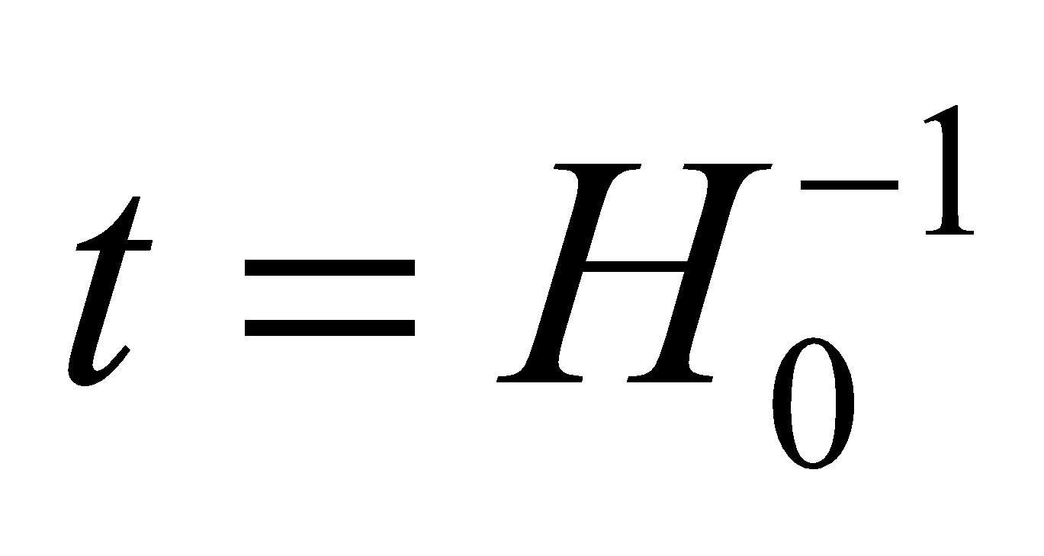 for the age of the universe but solve for *H*0 using *t* = 60 Gy as the age of the universe instead of the accepted value of *t* = 13.2 Gy (see Problem 39.55).

**Evaluate** The new value of the Hubble constant would be 

**Assess** The Hubble constant is not really a constant—it just seems like it is because it changes rather slowly at the current age of the universe.

**58. Interpret** We consider an earlier-tested cancer treatment using pions to kill cancer cells.

**Develop** The decay of the negative pion can be written as



Whatever the unknown particle is, the decay equation should obey the conservation laws, specifically conservation of charge, baryon number and lepton number. From Table 39.1, the negative pion has  and  The negative muon has  and 

**Evaluate** The left-hand side of the decay equation has only the pion, so  and  If the unknown particle were a proton with  then summed with the negative pion the right-hand side would have  This means *none* of the quantities would be conserved. If the unknown particle were an antineutrino with  then the right-hand side would have  This matches the left-hand side, so all the quantities would be conserved. The neutrino is the same as the antineutrino except with  so in this case the lepton number would not be conserved. The final choice, an up quark, is not valid, since individual free quarks are never observed.

The answer is (b).

**Assess** This exact decay equation,  was introduced in the text in Section 39.2.

**59. Interpret** We consider an earlier-tested cancer treatment using pions to kill cancer cells.

**Develop** Recall that the nucleus is positively charged, so there should be a Coulomb attraction between it and negatively-charged particles.

**Evaluate** The only negatively charged particle in the list is the negative pion.

The answer is (c).

**Assess** There's a second advantage to using negative pions over neutral pions  Since  mesons are charged, they can be deflected with magnetic fields. Thus, a beam of negative pions can be focused with magnets onto a tumor site.

**60. Interpret** We consider an earlier-tested cancer treatment using pions to kill cancer cells.

**Develop** The typical distance that a pion travels before decaying will be  where is the pion's lifetime. As always, the maximum speed is the speed of light.

**Evaluate** Since  we could argue that



The answer is (c).

**Assess** Actually, this argument neglects relativistic effects, specifically time dilation. The lifetime of the pion is defined for the particle is at rest. In terms of the variables from Chapter 33, we would say  Using Equation 33.3, the apparent lifetime of a fast-moving pion according to a stationary observer would be



Let's imagine that the pions are moving at 0.8*c* in the hospital rest-frame, then their apparent lifetime will be 1.7 times the actual lifetime, so 44.2 ns. In this case, the maximum distance for the beam line would be about 11 m. If the pions move faster, the beam distance can be even longer. There's no theoretical limit. However, practical considerations mean that pions will likely have kinetic energies of around 80 MeV, which corresponds roughly to speeds of 0.8c. Therefore, limiting the beam line to around 8 m is reasonable.

**61. Interpret** We consider an earlier-tested cancer treatment using pions to kill cancer cells.

**Develop** The negative pion has charge  and mass  We're asked what quark combination could give this.

**Evaluate** From Table 39.2, a particle with quarks would have a charge of  This therefore can't be the negative pion (in fact, this is the quark combination for the proton, see Figure 39.4). We could have also ruled this choice out because pions, like all mesons, are by definition made up of 2 quarks, not 3. Moving on, a particle with quarks would have a charge of where we have used the fact that an antiquark of a particular flavor will have the opposite charge of the quark with the same flavor. This could be the negative pion. The next choice has a charge of  This is not possible, since no free particles are known to have fractional charges. The last possibility is with a charge of  This doesn't match the negative pion, so by elimination  is 

The answer is (b).

**Assess** Notice that this result is similar to the quark content of the meson:  shown in Figure 39.5. We didn't consider the masses, but it turns out that most particles have more mass than just the sum of their quark masses. From Table 39.2, we might assume a particle made up of *d* quark and an anti-*u* quark would have a mass of around  but the negative pion actually is 15 times more massive than that. The extra mass comes from the internal energy between the strongly-interacting quarks.